**AHOY THERE FUTURE COLLEGE STUDENTS!**

[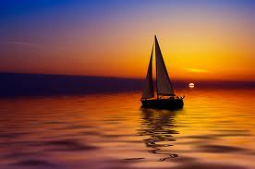](http://www.google.com/url?sa=i&rct=j&q=&esrc=s&frm=1&source=images&cd=&cad=rja&docid=Tk6-QKfENJZiXM&tbnid=0uem4nTm0jbT1M:&ved=0CAUQjRw&url=http://www.redbubble.com/people/enjoylife/works/276535-sailboat-against-a-beautiful-sunset&ei=8HXPUs2ZNufr2QW5xoCYCQ&psig=AFQjCNFgo-1PGQ6b84xXdWe2djz7T7mJHg&ust=1389414074283513)

**The Nebraska Association of Blind Students and the Nebraska Commission for the Blind and Visually Impaired would like to invite you aboard The 2014 Student Seminar Friday, March 14th- Sunday, March 16th at the Holiday Inn Midtown at 2503 S. Locust St. Grand Island, Nebraska 68801 for a weekend cruise through the ins and outs of the amazing voyage of college!**

**Learn how to work successfully with your college’s Disabilities Office by advocating for yourself.**

**Become familiar with the Tips and Tricks of getting around campus.**

**Be the life of the dorm room party scene with our “Build Your Own Social Event” activity!**

**Ask panels of experienced blind college students your questions about the voyage of earning a college degree.**

**“A ship in the harbor is safe, but that is not what ships were built for”**

**–John Augustus Shedd**

**YOU have an ocean of opportunity ahead of you. Drop anchor at our seminar to gather wind in the sails of your potential!**