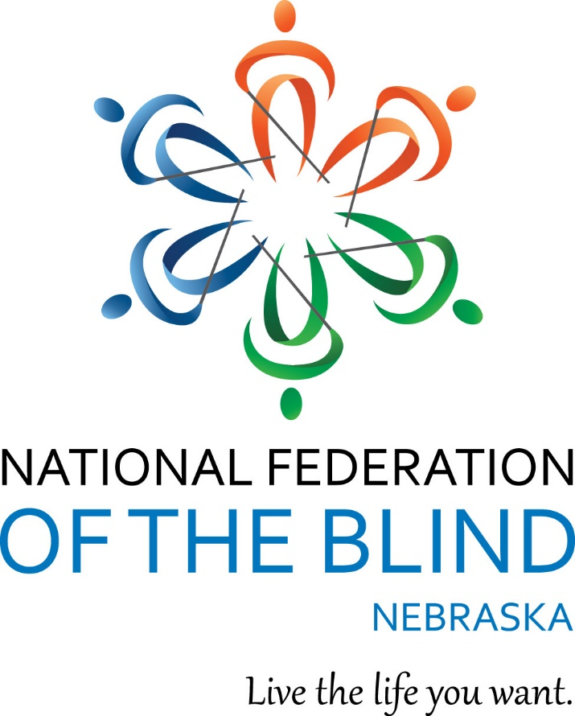

**National Federation of the Blind of Nebraska**

**Navigating The New Frontier**

**53rd Annual State Convention**

April 11 – 14, 2024

Gering Civic Center

1050 M Street

Gering, NE 69341

**NATIONAL FEDERATION OF THE BLIND PLEDGE**

I pledge to participate actively in the efforts of the National Federation of the Blind to achieve equality, opportunity and security for the blind; to support the policies and programs of the Federation; and to abide by its constitution.

**Welcome from the Officers and Board of Directors**

Officers:

President, Jamie K. Richey, Lincoln, NE

First Vice President, Christine Boone, Lincoln, NE

Second Vice President, Bob Burns, Omaha, NE

Secretary, Kimberly Scherbarth, Kearney, NE

Treasurer, Cheryl Livingston, Lincoln, NE

Members of the Board of Directors:

Nancy Coffman, Lincoln, NE

Geralyn K. Konruff, Chappell, NE

Karen Lemmon, Whitney, NE

Maura Loberg, Lincoln, NE

Rachna H. K. Marsh, Omaha, NE

Linda Mentink, Columbus, NE

The National Federation of the Blind of Nebraska knows that blindness is not the characteristic that defines you or your future. Every day we raise the expectations of blind people, because low expectations create obstacles between blind people and our dreams. You can live the life you want; blindness is not what holds you back. Together with love, hope and determination, we transform dreams into reality.

Connect with the National Federation of the Blind of Nebraska!

Like on Facebook: @nebraskasblind

Follow on X: @nfbn

Subscribe on YouTube: @NFBNE

Visit Online: http://www.ne.nfb.org.

**We wish to extend sincere gratitude to this year’s convention sponsors!**

ALLO Fiber

Creating, Connecting, and Serving Gigabit Communities Since 2003

ALLO Fiber, founded in Imperial, Nebraska, in 2003, is a telecommunications company offering fiber telephone, long-distance, broadband, internet, and television to residents and businesses. ALLO currently provides communications services to 40 cities across Nebraska, Colorado, and Arizona. ALLO has developed a world-class network to expand business opportunities, create jobs, and improve quality of life. We at ALLO take immense pride in providing residents and businesses with unmatched entertainment and communications options. It is our mission to create, connect, and serve Gigabit communities.

(866) 481-2556

[www.allocommunications.com](http://www.allocommunications.com)

@AlloFiber on Facebook, Instagram, X, YouTube, and LinkedIn

Christian Record Services, Inc.

Empower People Who are Blind to Engage Their Communities, and Embrace the Blessed Hope

Each year, Christian Record Services, Inc. impacts thousands of lives through services provided to them without cost. All who are legally blind or have physical impairments that prevent them from holding reading material or focusing on ink print are eligible for the following free services:

* Full-Vision Books
* Zoo Buds
* National Camps for Blind Children
* Gift Bibles and Study Guides
* Subscription Magazines
* PhoneFaith
* Naomi Chapman Turner Library for the Blind

Christian Record Services, Inc. is a ministry of the Seventh-Day Adventist Church in North America, serving people of all faiths and walks of life who are blind worldwide.

(402) 488-0981 option 3

services@christianrecord.org

[www.christianrecord.org](http://www.christianrecord.org)

@crsbfriends on Facebook, Instagram, X, and LinkedIn

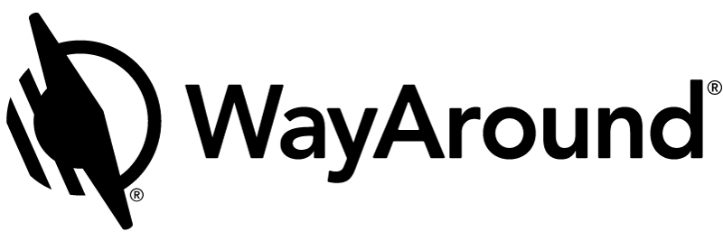

WayAround®

See beyond the limits of a visual world.

Born from the minds of two architects with vision loss, WayAround is more than just a revolutionary product. It's a movement led and fueled by people who may not have great eyesight, but who definitely have a vision. WayAround is an app for your smart device that provides on-demand details about everyday things. The simple tag-and-scan approach lets you quickly and easily identify things around you. WayAround was started with a can-do practicality and a lofty purpose: to provide limitless opportunities for people with vision loss. WayAround is providing accessible information at this year's convention. A WayTag will be placed on your badge when you check in at registration. Then, scan the WayTag with your iPhone or Android device to get the convention agenda, exhibitor packet, and other information. Download the free WayAround app for iOS or Android.

(888) 898-4465

connect@WayAround.com

www.WayAround.com

@WayAroundTools on Facebook, X, YouTube, and LinkedIn

**The National Federation of the Blind of Nebraska Welcomes Our Honored Guests!**

**National Representative: Carla McQuillan, Board Member, National Federation of the Blind**

The youngest of 4 children, Carla was born and raised in Southern California. She experienced a sudden loss of vision when she was 10 years old, which was diagnosed as Stargardt disease. She lost all central vision and was unable to read standard print without magnification. Because of her remaining peripheral vision, Carla did not "look blind," so she was not taught braille or any other alternative techniques of blindness. She had extraordinarily little experience with blind people. The only blind person she knew was her brother, and he was forever using his blindness as an excuse for standing on the sidelines. Carla knew that this was not the life she wanted and was determined to do everything in her power to convince the world that she was not blind.

 Despite her lack of Braille instruction, Carla graduated from high school with honors, and attended Humboldt State University. The reading load in college proved to be too intense, and she saw her grades begin to suffer. While struggling through her first year in college, she met her husband, Lucas. They were married and moved to San Diego, where Lucas completed his master’s degree. Carla was happy to put off her own education to support Lucas through graduate school. She got a job as a Montessori Preschool teacher.

Their daughter Alison was born in 1983. In 1985 the family moved to Illinois, where Lucas pursued his Doctorate and Carla completed her undergraduate degree. The staff at the university’s disabled student's services office told her how difficult Braille would be to learn and how inefficient it would be. Discouraged and defeated, Carla wondered if there was any hope for her future. Fortunately, she learned of the scholarship program through the National Federation of the Blind, and won a state scholarship from the Illinois affiliate in 1988. Attending the Illinois state convention changed her life. Her negative attitudes about blindness and about her own potential to be a successful professional were replaced by confidence and self-assurance that remain a hallmark of her character today.

After graduating with High Distinction from the University of Illinois in 1988, the McQuillans completed their family with the birth of their son Duncan. They moved to Oregon to be near Carla's family. Carla started her own Montessori preschool, which later expanded to include 3 schools and a Montessori Teacher Certification Program.

Carla has served as President of the National Federation of the Blind of Oregon for 26 years, from 1992 until the present, with a six-year break to focus on her businesses. She has also served for 16 years on the Board of Directors for the National Federation of the Blind. She has recently stepped down as the director of NFB Camp, after 28 years directing the Child Care program at National Convention.

**National Student Representative: Gene Kim, Secretary, National Association of Blind Students**

After first discovering the National Federation of the Blind as a 2019 national scholarship program winner, Gene has continued to grow as a member and leader in the National Association of Blind Students, the NFB Science and Engineering Division and the NFB of California. In just a few short years, the Federation has reshaped his blindness philosophy, and provided him with countless deep connections to mentors and friends. He is honored to be a Kenneth Jernigan Leadership in Service Program participant this year. Outside of the federation, Gene is a senior at Stanford University studying Symbolic Systems with a focus in Human-Computer Interaction and Accessibility. He is interested in making data visualizations, STEM education and design tools more accessible to blind people. In his free time, Gene loves listening to and playing music, experimenting with new recipes, venturing outdoors on hikes or camping trips, playing chess, and following the NFL.

**Michael Dalto**

Owner of High Note Consulting, Michael is a big, old benefits geek. He has provided training on disability benefits from Social Security for 35 years. Michael specializes in safety nets called "work incentives" for blind people that help protect essential benefits when people work. He consults with the National Federation of the Blind, the National Association of Blind Merchants, state blindness commissions and numerous other organizations. He is a firm believer in brief bios.

**Megan Macy**

From serving her country to serving students with visual impairments in the Nebraska Panhandle, Megan brings her love to serve. Soon after relocating to Gering, Nebraska, in 2019, Megan learned of the field of Vision within special education services. She decided to leave the general education classroom to explore the world of visual impairments so she could serve an underserved population of students right where she grew up. Having never worked with a student with a diagnosed visual impairment, she soon learned that many are in fact undiagnosed, misdiagnosed, or just waiting for services due to a shortage of Teachers of the Visually Impaired and Orientation and Mobility Specialists.

Megan is a Teacher of the Visually Impaired with Educational Service Unit 13 (ESU 13) in Scottsbluff, Nebraska. She currently serves all students from 0-21 with visual impairments across all 21 school districts within the Nebraska Panhandle. Megan is currently working on a master’s degree through the University of Nebraska-Lincoln to become a Certified Orientation and Mobility Specialist. In 2022 Megan was chosen as one of three American Printing House for the Blind scholars.

**John Olson**

As a former staff photographer for LIFE Magazine, John’s livelihood involved creating and distributing imagery. An invitation from the National Federation of the Blind led to a decade-long partnership with leaders and members of the organization. This partnership made him keenly aware of the need and desire for accessible imagery, instilling in him the belief that, for those without sight, access to tactile images represents a means to greater freedom, independence and equality. At Tactile Images, we fulfill our promise using our patented technology that integrates sensory stimulants through 3D, tactile renderings of images to deliver visual information to the brain through an enhanced, completely accessible, kinesthetic experience.

**Greg Steinmetz**

In January 2018, Greg joined the Guide Dogs of America | Tender Loving Canines team as the Senior Manager of Admissions & Graduate Services. He is responsible for recruitment and outreach, client support, and dormitory operations. Greg has received four guide dogs from GDA | TLC and is currently partnered with guide dog Sterling. Greg is a member of Lions Clubs International, the National Federation of the Blind of California and the California Guide Dog Users.

**Convention Details**

**Registration**

All convention attendees are required to register. Registration with the convention entitles you to the convention room rate and qualifies you to win door prizes. If you have pre-registered for the convention, please go to the registration area to pick up your registration packet. If you did not pre-register, you may do so in the registration area. The onsite registration fee is $30.00. Please note: NO meal tickets will be available for purchase onsite. We will adhere to the registration times strictly so that our registration workers can participate in all convention activities. See the agenda for a list of times and locations of the registration area.

**Information Table**

The information table is located between the Oregon Trail doors. Federationists will be on hand to answer any questions. This will also serve as the lost and found.

**Assistive Listening Devices**

An FM transmitter system is available for those who need assistance. Visit the information table for details.

**Guide Dog Relief Area**

The Guide Dog relief area immediately adjacent to the civic center is on the west side of the building. This grassy area is accessed by exiting the side door nearest to the Wild Cat Room. Please be courteous and pick up any waste and dispose of it in the provided trash can.

**Door Prizes**

A variety of door prizes will be drawn during each general session and at the banquet. Attendees must be registered with the convention to be eligible for a door prize and must be present to win. Drop off all door prize donations in the registration area during the assigned registration times.

**Agenda**

**Thursday, April 11, 2024**

6:00 - 8:00 p.m. Registration and Packet Pick-Up

**Platte River**

Cheryl Livingston, Coordinator, Registration Arrangements

7:00 - 10:00 p.m. Welcome to the Trails West Region

**Wild Cat**

Light Hors D’oeuvres and a cash bar will be available.

Christine Boone, Chair, Convention Arrangements Committee

**Friday, April 12, 2024**

7:30 - 9:00 a.m. Registration and Packet Pick-Up

**Platte River**

Cheryl Livingston, Coordinator, Registration Arrangements

7:30 - 8:30 a.m. Greater At-Large Chapter Meeting

**Pioneer**

This is the annual face-to-face meeting of the chapter. Chapter members are encouraged to attend, and guests are welcome!

Kimberly Scherbarth, President, National Federation of the Blind of Nebraska Greater At-Large Chapter

**General Session I**

**Oregon Trail**

9:00 a.m. Call to Order

Jamie K. Richey, President, National Federation of the Blind of Nebraska, Lincoln, NE

9:10 a.m. Invocation

Shane Buresh, Member, National Federation of the Blind of Nebraska, Lincoln, NE

9:15 a.m. Convention Logistics

Christine Boone, Chair, Convention Arrangements Committee, Lincoln, NE

9:25 a.m. Welcome to Gering

Kent Ewing, Mayor, City of Gering, Gering, NE

9:45 a.m. National Report

Carla McQuillan, Board Member, National Federation of the Blind, Florence, OR

10:15 a.m. Fit Break

10:20 a.m. National Student Report

Gene Kim, Secretary, National Association of Blind Students, Cupertino, CA

10:40 a.m. RTBS: 50 Years of Service

Bekah Jerde, Executive Director, Radio Talking Book Service, Omaha, NE

11:05 a.m. Nebraska Voter ID Education

Beckie Cromer, Project Manager, Nebraska Secretary of State – Election Division, Lincoln, NE

11:30 a.m. Adjourn

11:30 a.m. - 6:00 p.m. Exhibits

**Chimney Rock**

Refer to the exhibitor packet for a list of exhibitors and descriptions.

Note: Prove you have visited all the exhibitors by getting your exhibitor card punched at each table and win some cash! The cards will be collected, and a drawing will take place on Sunday morning. Must be present to win.

12:00 - 1:00 p.m. Keynote: Making the Impossible Possible

**Wild Cat and Dome Rock**

John Olson, CEO, Tactile Images, Chatham, NY

1:00 - 5:00 p.m. Registration and Packet Pick-Up

**Platte River**

Cheryl Livingston, Coordinator, Registration Arrangements

1:15 - 5:00 p.m. All Systems Go: How to Launch a Successful Job Search

**Pony Express**

Prepare for takeoff into your dream career! Are you truly equipped to secure the job you desire? Is your resume up to par? Or perhaps a curriculum vitae would better suit your goals. Are you tapping into the right job listings tailored to your expertise? And when it comes to interviews, do you possess genuine experience? These pivotal questions and more will be meticulously addressed at this year’s employment seminar. Join us for an immersive afternoon of practical guidance tailored to each individual job seeker. No pompous speeches, no empty cheers. This session will delve deeply into the nitty-gritty of job acquisition, ensuring that, when we conclude, you’ll possess the precise tools to present yourself in the best possible light. Don’t miss this opportunity to elevate your career prospects!

Christine Boone, Facilitator

1:15 - 3:00 p.m. Are You Ready for a Guide Dog?

**Pioneer**

Curious about guide dogs? Ever wondered what it would be like to own one? In this session, we will discuss benefits of Guide Dog Mobility, program requirements, application process, and program overview.

Greg Steinmetz, Senior Manager, Admissions & Graduate Services, Guide Dogs of America|Tender Loving Canines

3:15 - 5:00 p.m. How to Get Disability Benefits from Social Security, Go to Work and Live to Tell About It

**Pioneer**

If you get disability benefits from Social Security and you're confused about the rules, you're not alone. If you are baffled and worried about what would happen to your benefits if you went to work or increased your earnings, you're also in good company. Most people are confounded by Social Security! This presentation provides the basics about Social Security Disability and SSI benefits – who is eligible, how much the benefit amount can be, income and asset limits, which medical benefits are provided, and how to apply. Most importantly, the session explains how work affects these benefits, how to use safety nets called "work incentives" that help protect benefits when you work, how the work rules are better for blind people, and how to get free help using work incentives. Feel free to ask any questions you have about Social Security.

Michael Dalto, Owner, High Note Consulting, LLC

6:00 - 7:30 p.m. Chuckwagon Stories

**Wild Cat and Dome Rock**

Enjoy dinner as retired teacher and historian, Allan Maybee, will share pioneer tales and native American legends and lore during this adventure through the frontier.

**Following will be the National Federation of the Blind of Nebraska Board of Directors meeting which is open to all.**

7:30 p.m. Resolutions Committee

**Wild Cat and Dome Rock**

All attendees are encouraged to attend, as this is where you will learn about the resolutions for this year. Resolutions which pass the committee will then be voted on by the membership during general sessions of the convention. Resolutions are the birthplace of what becomes the policy and action of our affiliate.

Barbara Loos, Chair, Resolutions Committee

8:30 - 10:30 p.m. Victory Underground

**Wild Cat and Dome Rock**

Too rockin' for country, Too country for rock!

Sponsored by Richey’s Vending. Tap your toes and swing your hips to the tunes of Victory Underground! No cover charge; a cash bar will be available.

**Saturday, April 13, 2024**

7:30 - 8:00 a.m. Nominating Committee

**Pony Express**

This is the only closed meeting within the National Federation of the Blind of Nebraska and consists of a delegate from each chapter and division.

Christine Boone, Chair, Nominating Committee

8:00 - 10:00 a.m. Registration and Packet Pick-Up

**Platte River**

Cheryl Livingston, Coordinator, Registration Arrangements

8:30 - 11:30 a.m. Exhibits

**Chimney Rock**

Refer to the exhibitor packet for a list of exhibitors and descriptions.

Note: Prove you have visited all the exhibitors by getting your exhibitor card punched at each table and win some cash! The cards will be collected, and a drawing will take place Sunday morning. Must be present to win.

8:30 - 10:00 a.m. Nebraska Association of Blind Students Annual Business Meeting

**Pioneer**

Join us, whether you are a high school student getting ready for college, an adult learner taking a different path, an experienced college attendee, or an educator working in the field of educating blind and low vision students; this is the meeting for you! Learn about NABS and get involved!

Rachna H. K. Marsh, Vice President, Nebraska Association of Blind Students

8:30 - 10:00 a.m. Fitness 101

**Pony Express**

By the end of "Fitness 101," you'll leave feeling empowered, inspired and equipped with the knowledge and confidence to embark on your fitness journey with purpose and determination. Whether you're looking to transform your body, boost your energy levels, or enhance your overall well-being, this breakout is your gateway to unlocking the full potential of your physical health. Take the first step towards a fitter, stronger and healthier you!

Jessica Beecham, Facilitator

10:15 - 11:45 a.m. Senior Division Annual Business Meeting

**Pioneer**

Unfortunately, many blind and visually impaired seniors believe that if blindness comes during their later years, life's major activities must end. We know differently and we want to share our knowledge with those who hunger for it. Blindness in and of itself is not a barrier to living life, not when engaging in leisure, learning, living, or leadership. Come join us to explore the circle of life and blindness. You need us, and we need you.

Robert Newman, President, National Federation of the Blind of Nebraska Senior Division

10:15 - 11:45 a.m. Designing a Life of Wholeness

**Pony Express**

Learn how to live a life of design through wellness and the balancing of mind, body and spirit. Get tricks for goal setting and self-empowerment, and tools you can use in your journey.

Becca Stevens, Owner, Trifecta Wholeness Consulting, LLC

12:00 - 1:00 p.m. Keynote: From Boots to Roots

**Wild Cat and Dome Rock**

Megan Macy, Teacher of the Visually Impaired, Educational Service Unit 13, Gering, NE

**General Session II**

**Oregon Trail**

1:30 p.m. Call to Order

Christine Boone, First Vice President, National Federation of the Blind of Nebraska, Lincoln, NE

1:35 p.m. Invocation

Nancy Oltman, Member, National Federation of the Blind of Nebraska, Hastings, NE

1:45 p.m. Presidential Report

Jamie K. Richey, President, National Federation of the Blind of Nebraska, Lincoln, NE

2:05 p.m. Together Towards Tomorrow: Our Experience at Washington Seminar

Jessica Beecham, Owner, JB&K Services, LLC, Colorado Springs, CO

2:25 p.m. Empowering Blind Individuals, Promoting Opportunities and Building Belief in the Blind

Carlos Servan, Executive Director, Nebraska Commission for the Blind and Visually Impaired, Lincoln, NE

3:00 p.m. Fit Break

3:05 p.m. A Rat's Tale

Maura Loberg, Board Member, National Federation of the Blind of Nebraska, Lincoln, NE

3:25 p.m. Curveballs and Home Runs: Exploring the Heart of Beep Baseball

Amy Sweigard, Right Fielder, Sirens Beep Ball, Omaha, NE

3:45 p.m. Why Am I a Federationist?

Karen Lemmon, Board Member, National Federation of the Blind of Nebraska, Whitney, NE

4:10 p.m. Reports and Resolutions

4:30 p.m. Adjourn

5:30 p.m. Portrait Studio

**Platte River**

Dress in your best and smile for the camera! The Historians Committee needs a current photo of you for archival purposes.

6:00 p.m. Cocktail Reception

**Wild Cat and Dome Rock**

Preview the items to be auctioned off after the banquet, purchase a duck for the lucky ducky game and have a cocktail with friends.

7:00 p.m. Annual NFB of Nebraska Banquet

Barbara Loos, Master of Ceremonies, Lincoln, NE

Invocation: Kimberly Scherbarth, Secretary, National Federation of the Blind of Nebraska, Kearney, NE

Keynote Address: Carla McQuillan, Board Member, National Federation of the Blind, Florence, OR

NFBN Scholarship Presentation: Bob Burns, Chair, Scholarship Committee, Omaha, NE

Get on the PAC Plan: Barbara Loos, Chair, PAC Plan Committee, Lincoln, NE

9:00 - 11:00 p.m. Trivia and Annual Auction

**Wild Cat and Dome Rock**

Grab your friends and join in the fun! Items will be auctioned off between rounds, and a cash bar will be available!

Deb and Jeff Altman, Facilitators

**Sunday, April 14, 2024**

7:30 - 8:30 a.m. Non-Denominational Devotions

**Wild Cat**

Christine Boone and Linda Mentink, Facilitators

**General Session III**

**Oregon Trail**

9:00 a.m. Call to Order

Jamie K. Richey, President, National Federation of the Blind of Nebraska, Lincoln, NE

9:05 a.m. Invocation

Linda Mentink, Board Member, National Federation of the Blind of Nebraska, Columbus, NE

9:10 a.m. Minutes of the 2023 NFB of Nebraska State Convention

Kimberly Scherbarth, Secretary, National Federation of the Blind of Nebraska, Kearney, NE

9:20 a.m. 2023 Annual Treasurer's Report

Cheryl Livingston, Treasurer, National Federation of the Blind of Nebraska, Lincoln, NE

9:30 a.m. Roll Call of Chapters and Divisions

A. Greater At-Large Chapter

B. Lincoln Chapter

C. Omaha Chapter

D. Nebraska Association of Blind Students

E. Senior Division

10:00 a.m. Fit Break

10:05 a.m. Resolutions Committee Report

Barbara Loos, Chair, Resolutions Committee, Lincoln, NE

10:15 a.m. Scholarship Awards

Bob Burns, Chair, Scholarship Committee, Omaha, NE

10:25 a.m. Nominating Committee Report

Christine Boone, Chair, Nominating Committee, Lincoln, NE

10:30 a.m. Election of Officers

10:50 a.m. Final Remarks

11:00 a.m. Adjourn and Happy Trails!

**A Special Thanks from the President**

So much goes into putting on a convention, and it wouldn’t be possible without the talents of so many. Each one of you makes this organization what it is today! Below is a short list of people who worked behind the scenes to make this convention a success. Thank you, thank you!

The 2024 Convention Arrangements Committee

Christine Boone – Chair

Bob Burns – Sponsor and exhibitor Arrangements

Nancy Coffman – Door Prize Arrangements

Geralyn K. Konruff – Marshal Coordinator

Karen Lemmon – Door Prize Arrangements

Cheryl Livingston – Registration Coordinator

Rachna H. K. Marsh – Sponsor and Exhibitor Arrangements

Nancy Oltman – Auction Arrangements

Document Editing – Geralyn Konruff, Cheryl Livingston, and Linda Mentink

Document Editing and Braille Transcribing – Sahar Husseini

Driver/Go-To-Guy – Doug Boone

Pack Rat/Runner/Sounding Board/Supporter – Jeremy Richey

Photography/Videography – Sandy Wright

Sound – Jeremy Fifield and Shane Buresh

Transportation Arrangements – Ward and Kathleen Kinney

Cobblestone Hotel – Valerie Williamson and Staff

Gering Civic Center – Terri Tosh and Staff

Monument Inn – Shannon Brunner and Staff