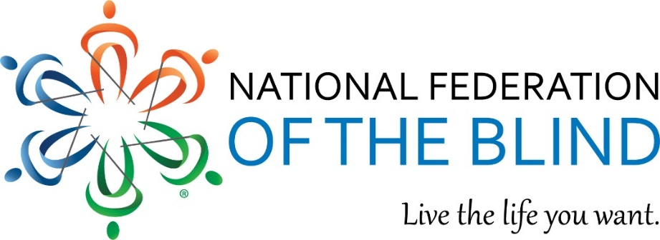

National Federation of the Blind
2023 Scholarship Program
Blind and low-vision high school seniors through grad school students, apply today!
Application Opens: December 1, 2022
Deadline: Midnight, eastern, March 31, 2023
$8,000 Awards & More
PLUS more gifts and opportunities to our thirty scholarship finalists!
Apply Today!
nfb.org/scholarships

How to Apply

During the four-month open period, read the rules and the Submission Checklist, complete the official Scholarship Application Form (online or in print), supply all required documents, and request and complete an interview by an NFB affiliate president. Read the Frequently Asked Questions (FAQ) page for more information.
Questions? Contact the NFB Scholarship Program; Chairperson Cayte Mendez
Email: Scholarships@nfb.org
Office: 410-659-9314, ext. 2415, (8 a.m. - 5 p.m. ET)

