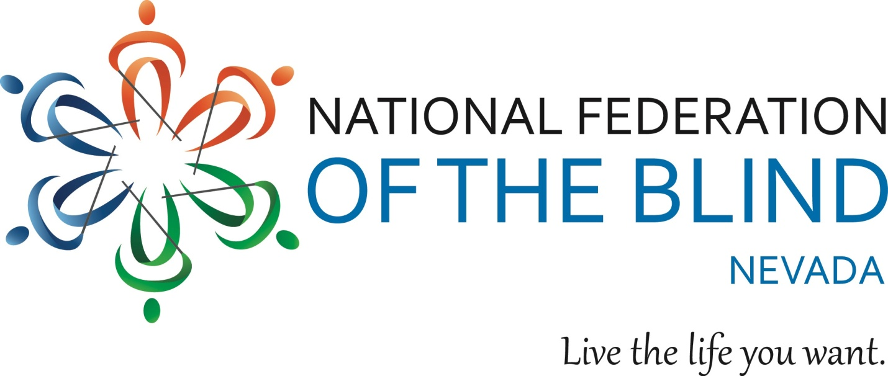

**2023 NFB of NEVADA UNITY SCHOLARSHIP INFORMATION**

The National Federation of the Blind of Nevada has broadened its commitment to blind college students and would like to recognize their achievements by awarding two students merit-based scholarships ranging from $1,000 to $1,500. All scholarships awarded are based on academic excellence, community service, and leadership.

ELIGIBILITY: To be eligible, applicants must be 1) legally blind in both eyes, 2) must have either been taking college courses or graduated from a high school in Nevada, 3) must be pursuing or planning to pursue a full-time, postsecondary course of study in a degree program at a Nevada institution in the 2022-2023 scholastic year (one scholarship will be allowed for an individual employed full-time while attending school part-time), and 4) must participate in the entire 2023 NFB of Nevada state convention including all of its scheduled scholarship program activities from November 10 through November 12, 2023, in person at the Nugget Casino Resort.

TO APPLY: Complete the application provided below; the application may also be obtained by emailing either the NFB of Nevada Scholarship Chair, Regina Mitchell, at [chefrdm@gmail.com](mailto:chefrdm@gmail.com), or by requesting a copy from the Northern Nevada or Southern Nevada Chapter Presidents. Please submit all documents listed on the application via e-mail to Frida Aizenman, Secretary, at [nfbfrida@gmail.com](mailto:nfbfrida@gmail.com).

DEADLINE: September 30, 2023.

Dispersement of Scholarship: Scholarship finalists will be contacted by the affiliate president one week after the scholarship deadline. All scholarship awards will be announced during the convention banquet.

**2023 NFB OF NEVADA UNITY SCHOLARSHIP APPLICATION**

Please type your responses in the spaces marked with an “X” or check the following items that apply to you by placing an “X” in between the brackets.

**PERSONAL INFORMATION**

Name: X

Date of Birth: X

Home Street Address: X

Home City, State, ZIP: X

Phone Number (please indicate Home or Cell): X

Email address: X

**EDUCATION**

College or university you will attend in the fall: X

Class standing (i.e. freshman, sophomore, etc.): X

Cumulative GPA: X

**MISCELLANEOUS**

[] I am legally blind.

[] I am a current NFB member.

[] I will attend college full time in the fall of 2023.

[] I am a resident of the State of Nevada.

[] I am attending school in the state of Nevada.

[] I commit to attend the entire NFB of Nevada state convention.

If none of the items apply to you then you are ineligible for a scholarship at this time.

**REQUIRED ATTACHMENTS**

In addition to the information above, please attach the following documents to your completed application:

1. Brief personal Essay introducing yourself to the committee. Consider the essay an opportunity to tell the committee who you are. Describe your strengths, achievements, and aspirations. What is important to you? Who do you hope to become? Has a particular person or experience changed your life? How has your blindness affected you? How do you manage it at school, on the job, and in interpersonal relationships? Include information about your goals for this scholarship. Keep in mind that scholarships are not awarded based on financial need. Your personal essay should be no more than five hundred words.
2. Two current letters of recommendation.
3. Current unofficial transcripts from the institution you are currently attending. If you have not completed study at an institution of higher learning, please provide your recent high school transcript.