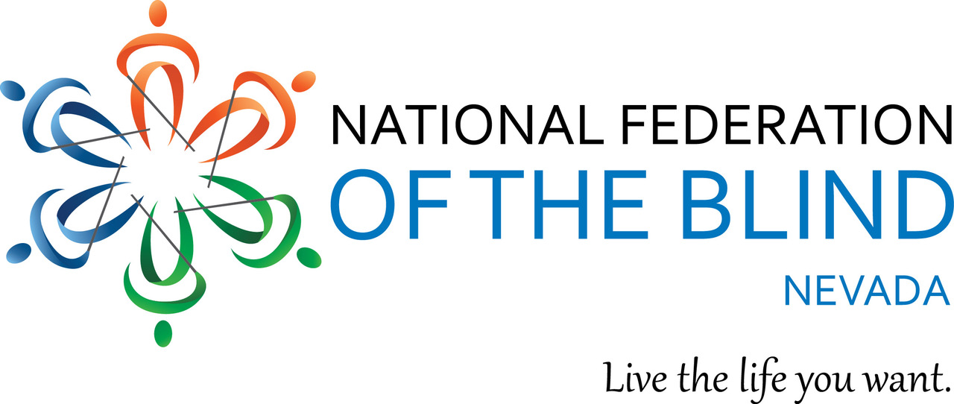

Calling all blind/low vision students in grades K - 12!

The National Federation of the Blind of Nevada is sponsoring an essay contest!

Tell us in 1 to 2 pages how you feel about blindness.

Elementary school students: First place $150. Second Place $100. Third Place $50.

Middle school students: First place $200. Second place $150. Third place $75.

High school students: First Place $250. Second Place $175. Third Place $100.

Essays must be accompanied by a cover letter containing the following information:

\*Your name, mailing address, phone number, e-mail, school and grade level. Essays may be submitted by either the student themselves or by a parent or teacher.

Email your entry to our NFB of Nevada secretary, Frida Aizenman, at nfbfrida@gmail.com

Entries must be received by no later than March 31st, 2024.

Finalists will be contacted by the affiliate president two weeks after the deadline.

All winners will be announced at the 2024 Nevada state convention banquet.

All winners will have transportation and be brought to the state convention.

The National Federation of the Blind knows that blindness is not the characteristic that defines you or your future.

Every day we raise the expectations of blind people because low expectations create obstacles between blind people and our dreams.

You can live the life you want; blindness is not what holds you back.