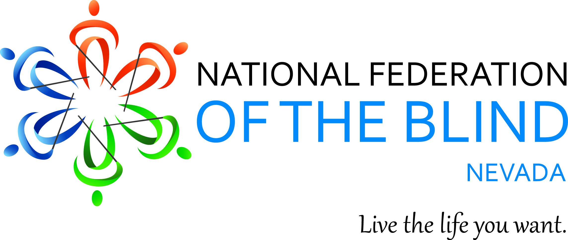

**Expect a weekend of energy as we Dare to Dream, Declare, and Deliver**

**The 2024 National Federation of the Blind of Nevada State Convention**

Friday, May 3- Sunday, May 5

Nugget Casino Resort

1100 Nugget Ave.

Sparks, NV 89431

The National Federation of the Blind knows that blindness is not the characteristic that defines you or your future. Every day we raise the expectations of blind people because low expectations create obstacles between blind people and our dreams. You can live the life you want; blindness is not what holds you back.

National Representative; Shaun Callaway

National Federation of the Blind First Vice President

National Federation of the Blind of Nevada Board of Directors

President: Mark Tadder

1st Vice President: Ramona Coker

2nd Vice President: Dawn Hyatt

Secretary: Frida Aizenman

Treasurer: Chun Chao

Board Member I: Regina Mitchell

Board Member II: Heather Destefano

Board Member III: Susan Moore

Board Member IV: Vacant

## Convention Registration Costs and Details

Convention registration will ensure you a ticket into our Friday Meet and Greet Reception, Saturday & Sunday Continental breakfasts, a box lunch, and Sunday Continental breakfast. You will also be automatically entered into the many door prize drawings that will occur throughout the convention proceedings. You must be in the room to claim your prize.

$15 Convention Pre-registration will open from March 12 and run until April 20.

$20 onsite registration will be available May 3-4.

$40 Banquet Ticket must be selected during pre-Registration by April 20.

### Guide Dog Relief Areas

East Tower - Across the street on 11th St. outside the parking garage

West Tower - Outside Orozko Restaurant, west entrance along the Victorian Plaza Avenue

### Friday, May 3, 2024

12:00PM to 4:30PM

Onsite convention Registration – Sierra Foyer

Whether you pre-registered or not, you will need to stop by our registration table to pick up your convention packet which will contain your name badge ensuring your entry into the Welcome Mixer, Saturday box lunch, and Continental breakfasts,

1:00PM to 4:30PM

Sierra 5

Blind and Low Vision Skills Breakout Sessions

Join in a set of 3 one-hour breakout sessions to introduce blindness skills with Raquel and Ryan O’Neal and members of the blind and low vision Independent Living life skills Team from NNCIL. As a participant, you will rotate through 3 breakout groups where you will learn about using a white cane for travel, smart phone accessibility techniques, and an introduction to using Braille.

Make sure to bring your smart devices and your favorite cane, but we will have some demos on hand if you have never tried one before.

6:30PM to 9:30PM

Welcome Reception

Sierra 1

The National Federation of the Blind of Nevada invites you to mix, mingle, and network with Federation members and distinguished guests, all while enjoying appetizers and drinks.

**Saturday, May 4, 2024**

8:00AM to 9:00AM

Continental Breakfast

Sierra 1

Sierra Pre-function foyer (Level 2)

9:00AM – 9:15AM

Sierra 1

Welcome Ceremonies

NFB Pledge (found at end of agenda)

9:15AM -9:45AM

National Report

Shaun Callaway, NFB National Representative

9:45AM-10:00AM

Nevada Affiliate Report

Mark Tadder

National Federation of the Blind of Nevada President

10:00AM to 10:30AM

Legislative Update

Becky Jayakumar, NFB Nevada Legislative Director

10:30AM – 10:45AM – Morning Break

10:45AM – 11:15AM

Chapter Reports

Southern Nevada Chapter, Becky Jayakumar, Chapter President

Southern Nye Chapter, Susan Moore, Chapter Board Representative

Northern Chapter, Ramona Coker, Chapter President

11:15AM – 12:00PM

NFB Newsline

Program and funding update

12:00PM – 2:00PM

Lunch – Sierral 1

A box lunch will be provided to anyone who registered and wearing a name badge.

2:00PM – 3:00PM

Adaptive Cooking -Tips and Tricks

Chef Regina

3:00PM – 3:45PM

General Board Meeting

3:45PM – 4:00PM -Afternoon Break

4:00PM – 5:00PM

NFB Philosophy 2024

Panel Discussion

5:00PM

Adjournment

6:00PM to 9:00PM

Dinner Banquet

Sierra 1

In Federation fashion, come dressed to impress as we celebrate year 2024 with awards ceremony and keynote address by National Representative, Shaun Callaway. Our banquet will also include great NFB fellowship, door prizes, exciting live auction baskets, and presentation of the $3,000 and $2,000 student scholarship winners.

**Sunday May 5, 2024**

9:00AM - 10:00AM

Continental Breakfast – Sierra 1

10:00AM – 12:00NN

Business Meeting

Treasurer’s Report – Chan “Allen” Chao, Treasurer

Membership Report – Ramona Coker, Membership Director

Resolutions – Frida Aizenman, Resolutions Chair

Affiliate Board Election

Nomination Committee Presentation – Mona Coker, Chair

Due to the change in moving the convention this Spring, all nine Board positions are up for election this year. The board positions of President, 1st Vice-President, 2nd Vice-President, Treasurer, and Secretary will be elected for a 2-year term, The remaining four board positions - 1st, 2nd, 3rd and 4th Board positions will be elected for a one year term as indicated in our State constitution.

12:00PM – Adjournment

See you all next year!

NFB Pledge

I pledge to participate actively in the effort of the National Federation of the Blind, to achieve equality, opportunity, and security for the blind to support the policies and programs of the Federation and to uphold its constitution.