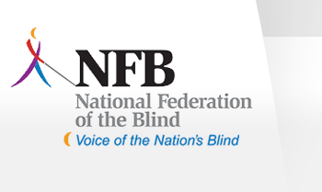
COME ONE!! COME ALL!!
To an old fashioned homemade Ham and Bean Church Supper. The proceeds will go to benefit the NH Chapter of the National Federation of the Blind and our humble church in the hills of Dunbarton.
The menu will include:
Beans, Ham, Salad, Rolls, Beverage and Dessert.
Please come join us for fun, food and fellowship.
(Look for the sign-up sheet in the vestibule)
DATE: Friday, October 9, 2009
TIME: 5:00pm - 8:00 pm
PLACE: St. John's Church in Dunbarton
COST: $6.00 Adults
$3.00 Children (under 12)
Children under 3 yrs. of age -Free
Thanks! Hope to see you there!

