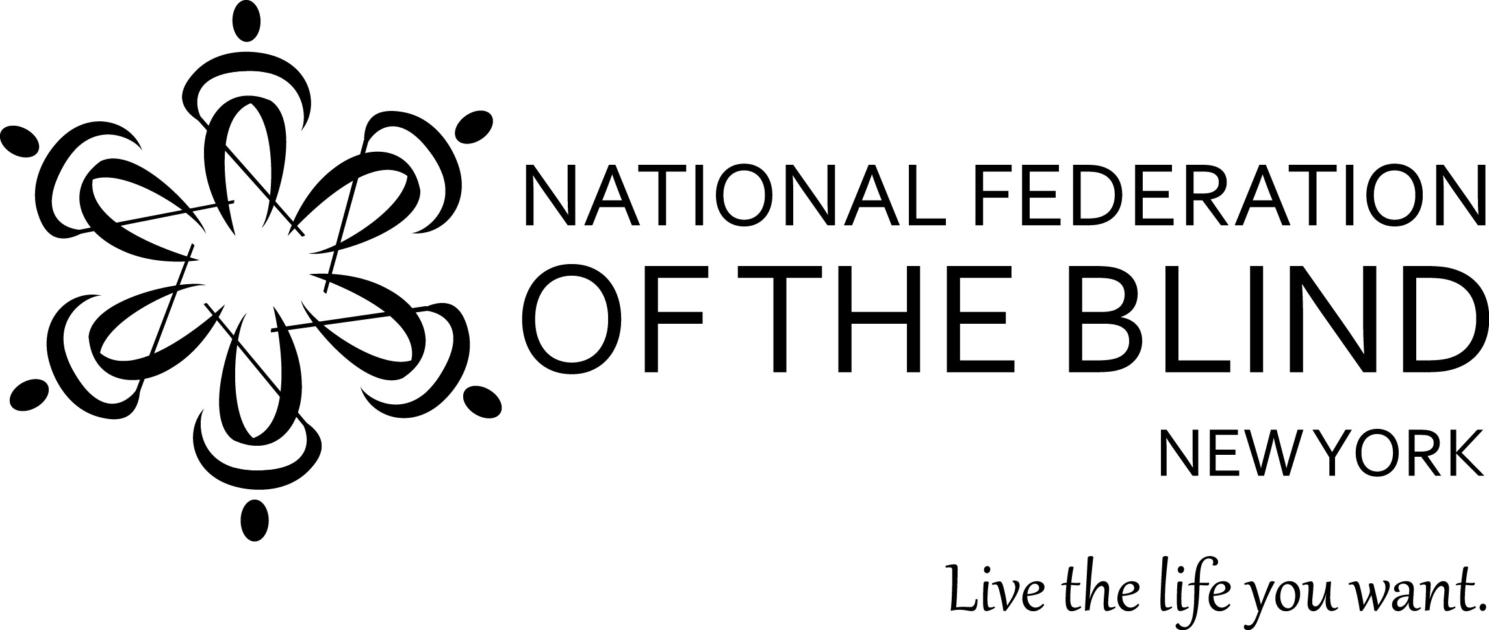

REGISTRATION FORM

National Federation of the Blind of New York State, Inc., 61st Annual Convention

Guest name(s) _____________________________________________________________________

Street address _____________________________________________________________________

City ___________________________________________ State______ Zip_________

Home phone______________________________ Mobile phone______________________________

Email address ______________________________

Circle one: king bed or 2 double beds. If you will also need a rollaway cot or a crib, see below.

Daycare needed for (number of) ___ children. Age(s) of child(ren) __________________

If the person sending payment is not a guest listed on this form, please provide this information:

Name _____________________________________________________ Phone _______________

Item | Quantity | Amount
Convention Registration per adult | ______ @ $15.00 | $
Box lunch Friday 11/17 | ______ @ $15.00 | $
Box lunch Saturday 11/18 | ______ @ $15.00 | $
Banquet Dinner Saturday 11/18: How many?  Prime rib ____ Chicken Francese ____  Eggplant Parmigiana ____  Any dietary restrictions: _________________ | ______ @ $30.00  (number of meals) | $
Hotel: Circle each night you will stay  Nov. 16 Nov. 17 Nov. 18 | ______ @ $85.00  (number of nights) | $
Rollaway cot ___ or crib ___ | ______ @ $15.00  (number of nights) | $
SUBTOTAL of all above items | XXXXXXXXXXXXX  XXXXXXXXXXXXX | $
5% discount of subtotal. Enter only if enve-lope is postmarked by October 15, 2017. | XXXXXXXXXXXXX  XXXXXXXXXXXXX | - $
TOTAL ENCLOSED (subtract discount if applicable) |  | $

Register online at www.nfbny.org
OR send this completed registration form with a check or money order payable to NFB of NYS to:
NFB of NYS Convention Committee, P.O. Box 205666 Sunset Station, Brooklyn, NY 11220

