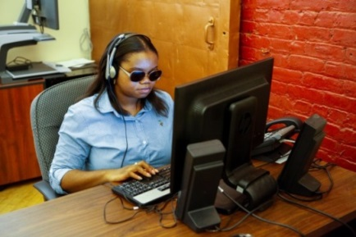
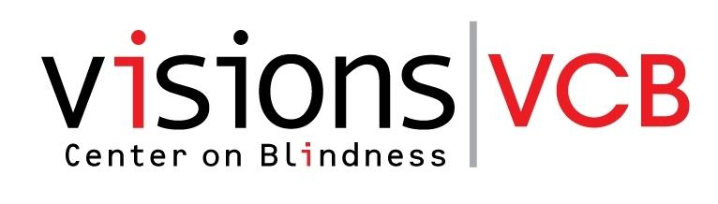
VISIONS Vocational Rehabilitation Center (VRC)
VCB is excited to offer SUMMER PROGRAM OPTIONS at the VRC.
ACCELERATE YOUR FUTURE & BECOME WORK READY OR DEVELOP AN ACTION PLAN FOR YOUR CAREER GOALS! Sponsored by the NY State Commission for the Blind for Blind and Visually Impaired Youth 18 to 21 (up to 22nd birthdate)
Pre-Employment Transition Services or Vocational Skills Training in a residential setting
SUMMER – June 18 – September 21, 2018 (15 weeks) *Enrollment will begin on June 18 until June 25. This program is for students not in school or college looking to complete a Vocational Skills Training course, become work ready and begin to look for job placement.
SUMMER – July 1 – July 31, 2018 and/or August 1 - August 31, 2018 (4 weeks) This program is for students attending or graduating from High School, presently in College or enrolled in another educational program who want to identify and develop an action plan for reaching your career goals.
The VRC programs are designed for students who are serious minded and want to:

- Identify a career goal
- Translate your skills and knowledge
into career opportunities
- Receive structured support by professional staff to meet your goals
- Overcome barriers to succeed
- Receive mentoring opportunities
- Participate in work site tours, visit 2 and 4 year colleges, and/or job shadowing experience
- Increase your communication and interpersonal skills, orientation and mobility skills and job seeking skills

Family members are encouraged to visit and support the students’ goals

VISIONS vocational rehabilitation center (VRC) is a newly built wheelchair accessible building designed specifically for youth and adults with vision loss. Located on the campus of VISIONS Center on Blindness (VCB) in Rockland County, NY, the VRC offers a state of the art technology and computer center, professional supportive program staff, all with high expectations for the students.

Contact your NYSCB Counselor TODAY to find out how you can be one of the lucky students to go to the VRC and participate. Limited slots are available. Contact Carmen Thorne at 212-625-1616, x107 cthorne@visionsvcb.org for more information, arrange a tour and to send a referral.

