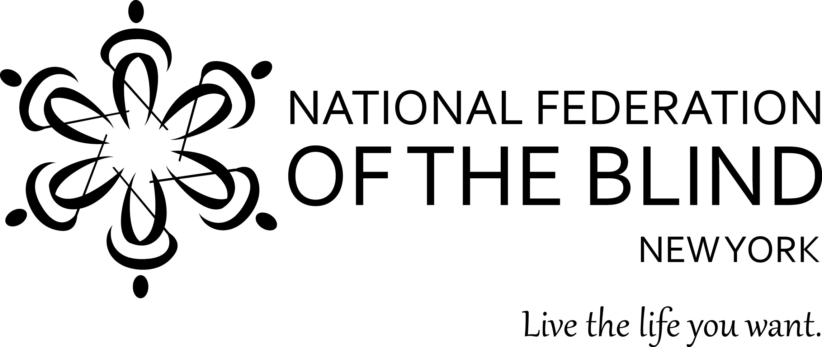

REGISTRATION FORM

National Federation of the Blind of New York State, Inc., 62nd Annual Convention
Guest name(s) _____________________________________________________________________
Street address _____________________________________________________________________
City ___________________________________________ State______ Zip_________
Home phone______________________________ Mobile phone______________________________
Email address ______________________________________________________________
Circle one: king bed 2 double beds Crib needed? ___ If you will need a rollaway cot, see below.
Daycare needed for (number of) ___ child(ren) Age(s) of child(ren) __________________
If you wish to request any particulars for your hotel room, please contact the office at 718-567-7821 or office@nfbny.org.
Please indicate which of the following you might be interested in attending a seminar about at convention:
Blind children __ Blind parents __ Students __ Seniors __ Guide dogs __ Other ____________________
Item | Quantity | Amount
Convention Registration per adult | ______ @ $15.00 | $
Box lunch Friday 10/19 | ______ @ $12.00 | $
Box lunch Saturday 10/20 | ______ @ $12.00 | $
Banquet Dinner Saturday 10/20: How many?  Stuffed Pork Chop ____ Eggplant Rollatini _____ Baked Stuffed Chicken Breast ____  Kosher? ___ Gluten-free? ____ | ______ @ $30.00 | $
Hotel: Circle each night you will stay  Thur. Oct. 18 Fri. Oct. 19 Sat. Oct. 20 | ______ @ $99.00  (number of nights) | $
Rollaway cot ___ | ______ @ $10.00  (number of nights) | $
SUBTOTAL of all above items | XXXXXXXXXXXXX  XXXXXXXXXXXXX | $
5% discount of subtotal. Enter only if enve-lope is postmarked by October 5, 2018. | XXXXXXXXXXXXX  XXXXXXXXXXXXX | Amount to subtract  $
TOTAL ENCLOSED (subtract discount if applicable) |  | $

Register online at www.nfbny.org

OR send this completed registration form with a check or money order payable to NFB of NYS to:
NFB of NYS Convention Committee, P.O. Box 205666 Sunset Station, Brooklyn, NY 11220

