I apologize if some of you receive this message more than once. I am dealing with an email issue.

**You Are Cordially Invited to Attend**

**The 62nd Convention of the National Federation of the Blind**

**Of New York State**

The National Federation of the Blind of New York State will hold its sixty-second annual convention in Buffalo, NY, from October 19-21, 2018. Please join us as we strive to build a network of expertise and encouragement among blind New Yorkers and work together to make a positive difference in the lives of blind people across New York State.

**Who Are We?**

The NFB of NYS is an organization of blind and visually impaired New Yorkers who believe that, with the appropriate training, attitude, and opportunities, blind people can live the lives we want.  NFB of NYS brings blind people together to support and learn from one another and to celebrate our achievements as we work together to improve the lives of the blind of New York.

**Our Convention Agenda**

It is our pleasure to welcome back, as our National Representative, Mr. Mark Riccobono, President of the National Federation of the Blind. We will be privileged to hear him share information about the ongoing work of the Federation nationwide.

The theme of this year’s convention will be *“Back to Basics”.* We’ll be looking at the main purposes of the Federation and revisiting our ultimate goals. We hope everyone will come away from convention feeling refreshed, rejuvenated and ready to carry the Federation spirit back to each of our communities.

On Friday, October 19, the day will be filled with break-out sessions and small group meetings. Among these will be the annual seminars of the various divisions of the NFB of NYS. These will include our Seniors Division, our Student Division, Guide Dog Division, Blind Parents Group, and our Parents of Blind Children Division. These meetings are interactive and open to all convention attendees, so please stop by!

Also, on Friday, we will host a town hall style meeting with Brian Daniels, Associate Commissioner of the New York State Commission for the Blind and Visually Impaired. Everyone is welcome to attend our board meeting, where among other things, the winners of our 2018 NFB of NYS scholarships will introduce themselves. Convention attendees are encouraged to explore our exhibit hall, where the latest technology will be on display and information pertinent to our community will be shared. In the evening, join us for our hospitality event! Meet and mingle with other Federation members in a relaxed atmosphere of food and fellowship.

All day Saturday the general sessions of the convention will provide us with the opportunity to hear presentations on topics that are important to blind people across New York and across the nation.

The excitement will continue during Our Saturday evening banquet, with an address by our keynote speaker, Mr. Mark Riccobono, the fun of our annual “horse race,” and prize giveaways. The banquet will come to a dramatic close with the presentation of our 2018 NFB of NYS scholarships.

Please see the “special notes” later in this letter.

On Sunday morning we will hold our annual business meeting to chart our course for the coming year. We will also consider the resolutions that the Convention deems vital for our future. We will hear Chapter and Division reports from around the state. We will then return home, revitalized and ready to live the lives we want, and to share our experiences and our learning with other blind members of our communities.

**Reservations, Room Rates and Registration**

This year’s convention will be held in Buffalo, at the Holiday Inn, 4600 Genesee Street, Cheektowaga, NY 14225. Please make all hotel reservations through the NFB of NYS office, by visiting [www.nfbny.org/conventions/details](http://www.nfbny.org/conventions/details) and completing our online registration form, or by filling out the attached registration form and returning it to the affiliate office. Room rates this year are $99 per night, including doubles and quads.

Using the same registration form, you will also be able to purchase your banquet ticket ($30) and pay your $15 convention registration fee. To make eating on the go easy during this fun and event-packed weekend, we also offer the option to purchase boxed lunches both Friday and Saturday, which can be ordered for $12 each when you register. **All payments including the hotel room must be made through the NFB of New York**. A five percent discount will be given to anyone who registers by October 5, 2018.

Limited financial assistance may be available through NFB of NYS to attend the convention. If you would like to apply to have part of your room or travel costs covered by the organization, please contact the President of NFB of NYS, Mike Robinson, (716-222-3632) for more information.

**Free childcare will be provided during all our events. Pre-registration for this service is required by October 1.**

**Please call the office at 718-567-7821 with any questions regarding this year’s convention.**

The convention is shaping up to be a tremendous event. Come to Buffalo and share in the excitement. I look forward to seeing everyone there.

Mike Robinson, President

NFB of New York

(716) 222-3632

*The National Federation of the Blind knows that blindness is not the characteristic that defines you or your future. Every day we raise the expectations of blind people, because low expectations create obstacles between blind people and our dreams. You can live the life you want; blindness is not what holds you back.*

SPECIAL NOTES

* The Commission for the Blind Town Hall Meeting be from 9:00 to 11:00 am on Friday, October 19th.
* The Board of Director’s Meeting will be from 11:00 am – 12:00 pm on Friday October 19th.
* Transportation from your chosen means to the hotel is simple this year. The Holiday Inn offers a shuttle from both the Buffalo Airport and the Depew Amtrak station to their facility. If traveling by bus, just ensure the bus stops at the Buffalo Airport. The phone number for the hotel to arrange a shuttle is 716-634-6969.
* Join us on the evening of Friday, October 19th for our New York Hospitality event! Activities include:

NFB Back to Basics Trivia and games,

Dance steps, including beginners’ classes, for all and

Personalized karaoke for the loudest state in the house.

Refreshments will be served! All are welcome.

* Our senior citizens are invited to join each other for lunch on Saturday at the convention. You can buy a box lunch at registration or buy it in advance when you register. We will discuss the possibilities of forming a Seniors Division in New York. This will address the problems of older people losing vision or just the problems of aging. Let's get together and talk. The room will either be in the agenda or announced during the convention session on Saturday morning.
* Student Division seminar and business meeting will be on Friday the 19th. Come make your voices heard.

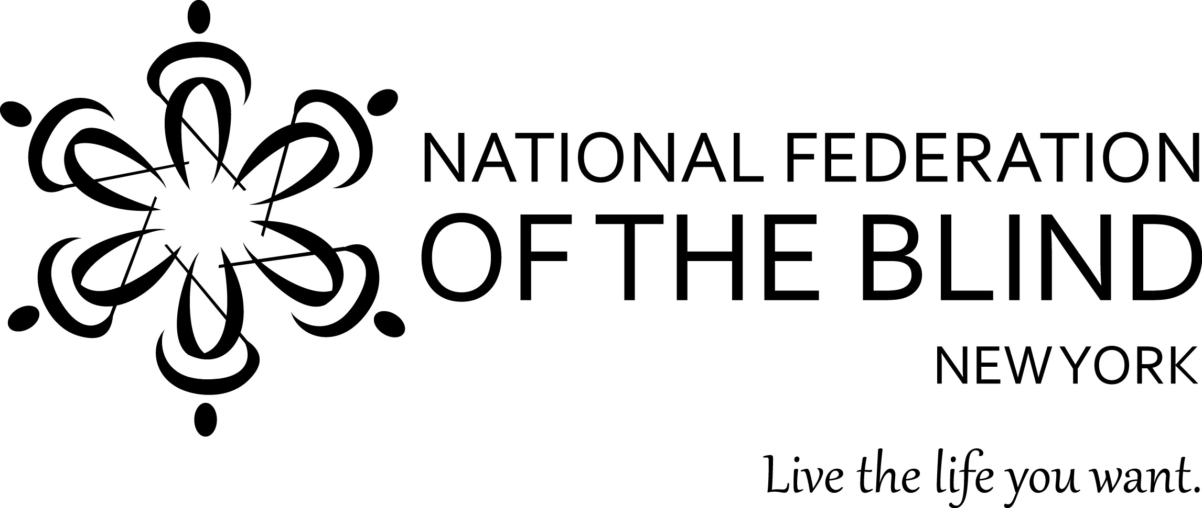

REGISTRATION FORM

National Federation of the Blind of New York State, Inc., 62nd Annual Convention

Guest name(s) _____________________________________________________________________

Street address _____________________________________________________________________

City ___________________________________________ State______ Zip_________

Home phone______________________________ Mobile phone______________________________

Email address ______________________________________________________________

Circle one: **king bed** **2 double beds** Crib needed? ___ If you will need a rollaway cot, see below.

Daycare needed for (number of) ___ child(ren) Age(s) of child(ren) __________________

**If you wish to request any particulars for your hotel room, please contact the office at 718-567-7821 or** [**office@nfbny.org**](mailto:office@nfbny.org)**.**

Please indicate which of the following you might be interested in attending a seminar about at convention:

Blind children __ Blind parents __ Students __ Seniors __ Guide dogs __ Other ____________________

|  |  |  |
| --- | --- | --- |
| **Item** | **Quantity** | **Amount** |
| **Convention Registration per adult** | **______ @ $15.00** | **$** |
| **Box lunch Friday 10/19** | **______ @ $12.00** | **$** |
| **Box lunch Saturday 10/20** | **______ @ $12.00** | **$** |
| **Banquet Dinner Saturday 10/20: How many?**  **Stuffed Pork Chop ____ Eggplant Rollatini _____Baked Stuffed Chicken Breast ____**  **Kosher? ___ Gluten-free? ____** | **______ @ $30.00** | **$** |
| **Hotel: Circle each night you will stay**  **Thur. Oct. 18 Fri. Oct. 19 Sat. Oct. 20** | **______ @ $99.00**  (number of nights) | **$** |
| **Rollaway cot ___** | **______ @ $10.00**  (number of nights) | **$** |
| **SUBTOTAL of all above items** | XXXXXXXXXXXXX  XXXXXXXXXXXXX | **$** |
| **5% discount of subtotal. Enter only if enve-lope is postmarked by October 5, 2018.** | XXXXXXXXXXXXX  XXXXXXXXXXXXX | **Amount to subtract**  **$** |
| **TOTAL ENCLOSED (subtract discount if applicable)** |  | **$** |

**Register online at** [**www.nfbny.org/conventions/details**](http://www.nfbny.org/conventions/details)

**OR** send this completed registration form with a check or money order payable to **NFB of NYS** to:

**NFB of NYS Convention Committee, P.O. Box 205666 Sunset Station, Brooklyn, NY 11220**