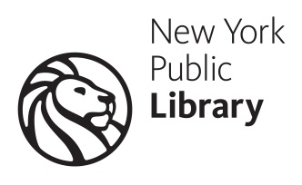
Accessible
Community, Culture, & Technology Fair!
For people who are blind, low vision, or physically disabled.
Wednesday, Nov 7th 12:30 PM – 5:00 PM
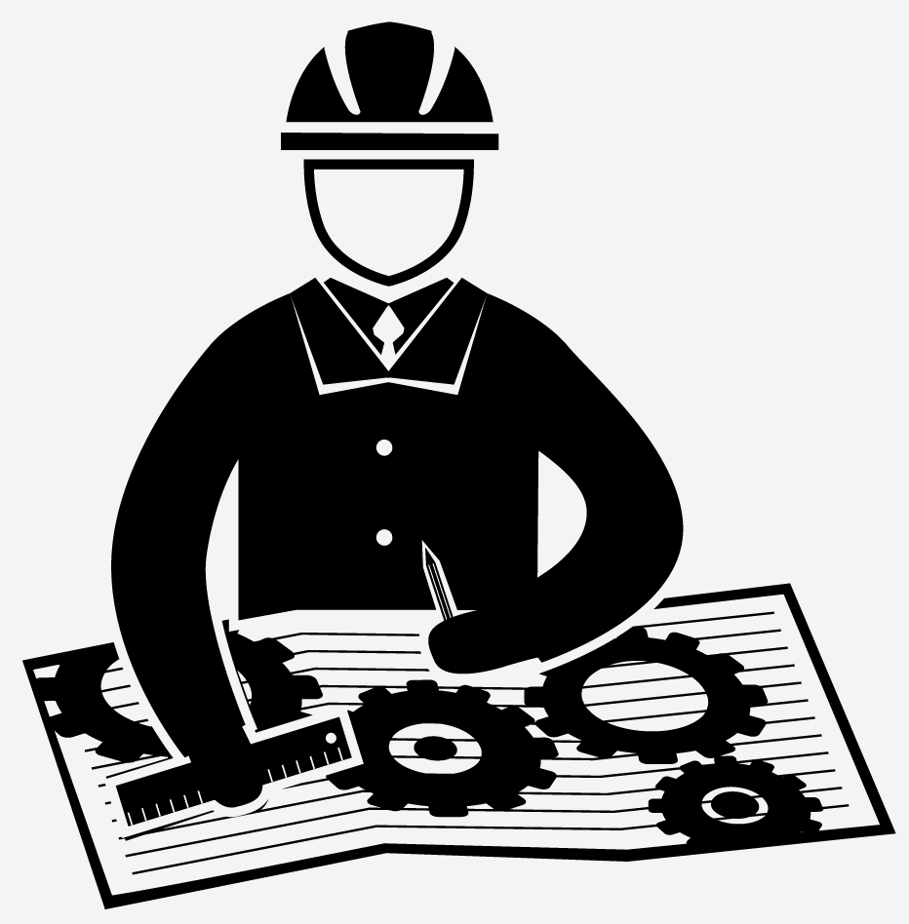
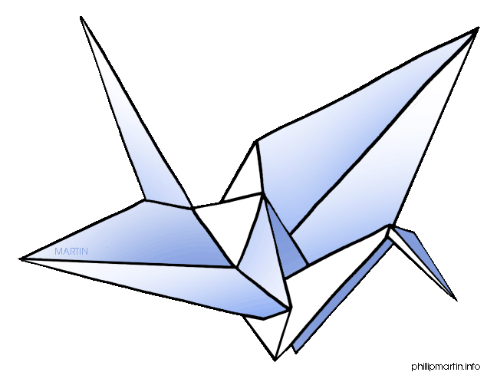
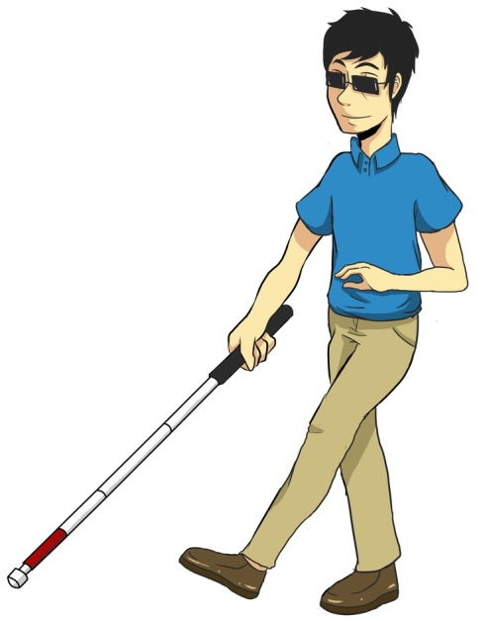
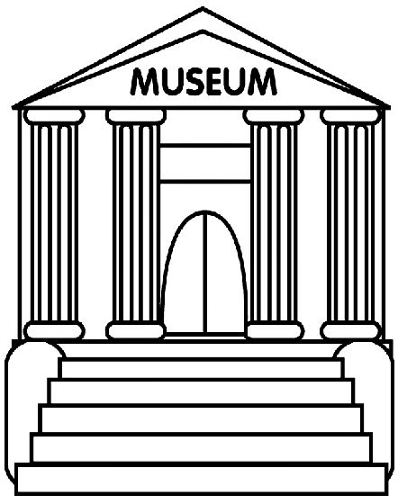

- Workshops on employment and skills building! Interview skills, job search tips and LinkedIn headshots.

- Visit 35 tables showcasing NYC’s accessible museums, cultural programs, education, entertainment, recreation, advocacy organizations, and adaptive technology

- Enjoy hands-on workshops and activities with technology, tactiles, arts, crafts, and robotics

- Experience our new verbal description/touch tours of the historic Stephen A Schwarzman Library
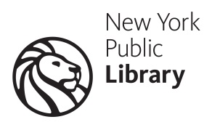
This event is FREE. No Registration Required.

Venue: NYPL’s Stephen A. Schwarzman Building,
42nd Street entrance (just West of 5th Ave).

