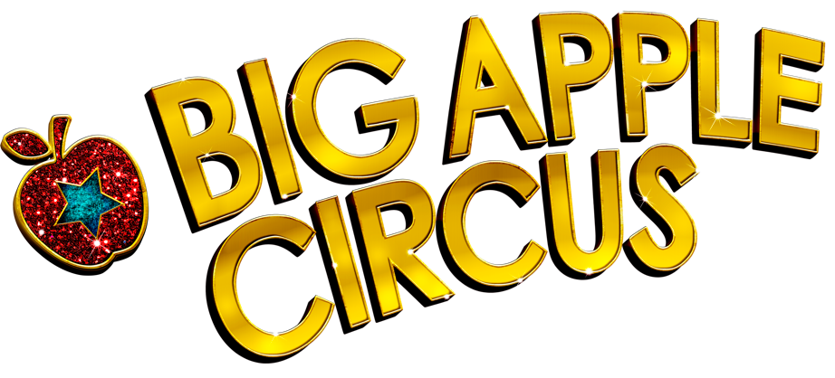

**DINNER AND SHOW IN THE DARK**

Thursday evening, December 5, 2019 at 5:00pm

Show at 7:00pm – Damrosch Park, Lincoln Center

PURCHASE TICKETS HERE:

<https://tickets.abigailskitchennyc.com/event/-dinner-in-the-Dark-at-Big-Apple-circus->

A complete 3 course dinner co-hosted by Abigail’s Kitchen and the Big Apple Circus! Don your blindfolds to experience the depth of perception your other five senses have to offer! Along with a gourmet meal and wine pairings for the adults, juice pairings for those who prefer. Enjoy our Full, Live, Simultaneous, Audio description and tactile experience of the all new 42nd year of the Big Apple Circus!

For group rates and financial assistance, contact [LLewis@BigAppleCircus.com](mailto:LLewis@BigAppleCircus.com)

To purchase your tickets by phone: (212) 673-8184

Dinner Co-Hosted by Accessible Play Spaces from Adaptive Work Places

Abigail’s Kitchen PunkinFutz

