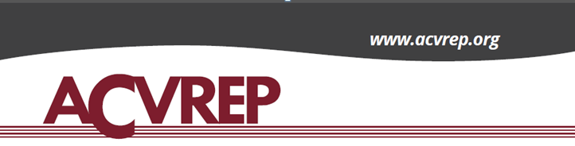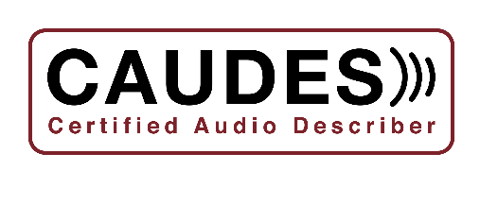

**REQUEST FOR INPUT – Certification for Audio Describers**

**OPEN FORUM ANNOUNCEMENT**

**Date**: Monday, October 24, 2022

**Time**: 4:30 PM to 6:30 PM Eastern Time

**Location**: Online via Zoom

**Language**: Forum will be conducted in English

Auto captioning will be available through Zoom

**Sponsor**: The Audio Description Subject Matter Expert (SME) Committee of the Academy for Certification of Vision Rehabilitation & Education Professionals (ACVREP)

We are inviting Audio Description writers, **especially those who are blind or have low vision,** to share their process in crafting description.

Those interested in speaking at the Forum may sign up to present for five to seven minutes. Please send your request to speak on the schedule **no later than Saturday, October 15, 2022, to:** [**comments@Acvrep.org**](mailto:comments@Acvrep.org)**.**

Everyone wishing to attend the Open Forum (both observers and presenters) must register at the following link to receive the Zoom information.

[**https://acb-org.zoom.us/webinar/register/WN_yE6JEvb-R2unhz6bOeRynA**](https://acb-org.zoom.us/webinar/register/WN_yE6JEvb-R2unhz6bOeRynA)**.**

Written submissions are also encouraged and can be submitted at any time but no later than **October 31, 2022, to:** [**comments@acvrep.org**](mailto:comments@acvrep.org)**.**

**Focus**

Those interested in participating are encouraged to focus their comments on the following topics:

* In what areas of Audio Description do you work?
* When crafting your description, what does your workflow look like?
* How do you gather the key visual information necessary to craft your description?
* How do you analyze and prioritize visual elements to include in your description in order to enhance listeners' understanding and experience of the content?

**Background**

Over the past three years, we have been working to establish a certification process for Audio Describers.

The certification will formally recognize individuals who demonstrate knowledge of, and proficiency in, Audio Description best practices across a wide range of formats and venues. Areas of practice include, but are not limited to, pre-recorded media, performing arts, museums, interactive displays, live events, and education.

To ensure that those who are sighted, blind, or have low vision experience an equitable certification process, we are reaching out to gather more information that could help us achieve this goal.

If you have questions about the Forum, please email them to: [comments@acvrep.org](mailto:comments@acvrep.org).

**###**