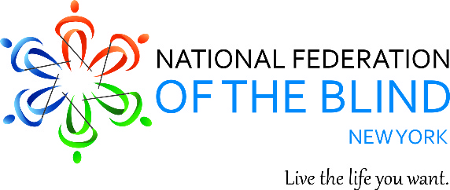
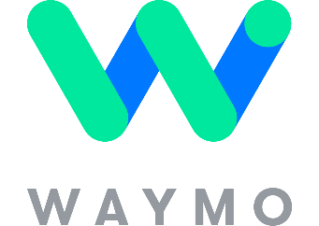
Please join the National Federation of the Blind of New York State, Inc. next Tuesday, October 8, 2024, for an exciting informative free presentation by Waymo.
The presentation will begin at 11 AM at the Irondequoit Town Hall, 1280 Titus Avenue, Rochester, NY 14617. It will be held in the Broderick room on the first floor. There will be an opportunity for a “Static Demonstration” of a Waymo vehicle in the Town Hall parking lot following the presentation.
Individuals who are blind or low vision will have an opportunity to explore the vehicle tactilely inside and out.
All who are interested in learning more about autonomous vehicles are welcome!
Technological advancements are occurring at an incredible pace. Just five years ago, fully autonomous self-driving vehicles seemed like science fiction. Today, you can easily hail a Waymo One autonomous vehicle in San Francisco or Phoenix, much like calling an Uber or Lyft.
This event is organized by the NFB of NYS, presented by Waymo and hosted by the Town of Irondequoit and its Supervisor, Andraé Evans.
For further information, please contact Aubrey Bird, President of NFB NYS, at (585) 739-6473.

