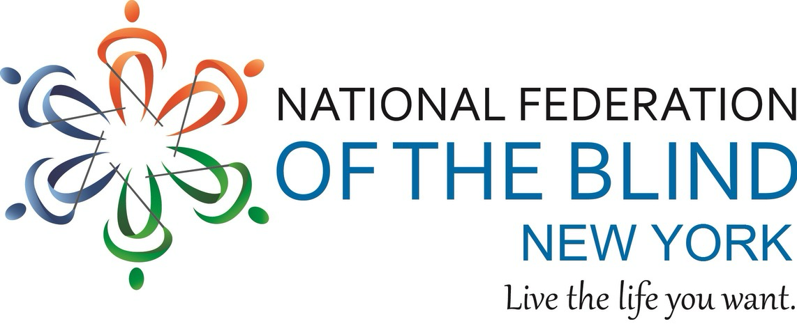
♿ Fully Accessible Venue

NFB Vanguard Chapter Holiday Party!

Get ready for a night of joy, laughter, music, and holiday magic!

DATE: Sunday, December 7
TIME: 4:00 p.m. – 10:00 p.m.
LOCATION: Bar Freda
ADDRESS: 801 Seneca Ave., Ridgewood, NY
(Fully Accessible Venue!)

ENTRY INFORMATION:
Entry is FREE! Food and drinks will be available for purchase at the bar.

DIRTY SANTA GIFT GAME:
Bring one wrapped gift that starts with the letter A or V and get ready for our hilarious Dirty Santa swap!

EAT, SIP & CELEBRATE:
Festive food, drinks for purchase, community joy, and holiday cheer.

HOLIDAY KARAOKE:
Sing your favorite holiday classics and enjoy lots of laughs and festive fun!

FESTIVE ATTIRE:
Wear your favorite Christmas sweater or dress in red or green!

RSVP by Friday, December 5:
Email: rashetabunting@first.vp@nfbny.org
Text RSVP: 347-337-4606

