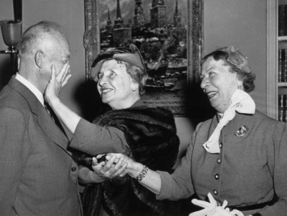

Happy Birthday Helen Keller
Deaf-Blind Awareness Celebration
When: July 2, 2013
Where: National Federation of the Blind
National Convention Deaf-Blind Division Meeting
Rosen Centre Hotel
9840 International Dr.
Orlando, FL 32819
Time: 6:30 – 9:30 PM
Great Guest Speakers: and Refreshements!

