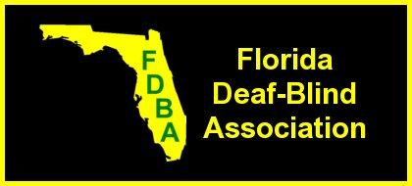
12055 SW Elsinore Dr.

President……………Vicky Magliocchino
Vice-President…….. Cheryl Rhodes
Treasurer………… Kathy Zarate
Secretary……. Roland Stetson
Board Members……David Roberts
Alexis Cabreras
Beth Bystrycki
Web Developer…….Theresa Wells

Florida Support Service Program (FSSP)
Coordinator……Darlene Laibl-Crowe
Port St. Lucie, FL 34987
www.fldeafblind.org

Greetings!

Florida Deaf Blind Association (FDBA), Inc is continuing to promote the No Deaf Blind Floridian Left Behind campaign.
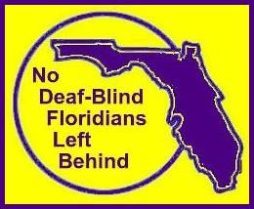
This project will help FDBA to gather data of Florida residents of ALL ages who have combined vision and hearing loss. This will help us to identify the need and location as well as providing statistics to gain funding and approach state legislators for effective laws and resources to enhance the quality of life for Deaf Blind Floridian on the job, in school, and in their community.

Please help us by sharing this with your consumers who have combined vision and hearing loss.

Step by step instructions and three forms are available:

- To complete the Online Form, click on this link:
www.fldeafblind.org/stepbystep.html

- To choose a format to print and complete by hand or to fill in a document to save as a file to send an email attachment, click on this link:
www.fldeafblind.org/registry.html

We believe this will lead to much more as we move forward with Florida Support Service Program (FSSP), where we recruit and train Support Service Providers (SSPs) to sight-guide, give visual information, assist in communication needs (voice and/orsign) and provide transportation for the Deaf Blind community throughout Florida.

For more information, please feel free to contact me.

Darlene Laibl-Crowe
Florida Deaf Blind Association, Inc.
Florida Support Service Program Coordinator
(386) 546-5706
dlcrowe@fssp.fldeafblind.org

