**What is Deaf-Blindness?**

***Varied degre****es of combined vision and hearing loss that impacts a person’s ability to function in daily* activities

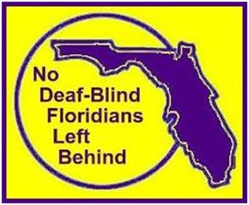The No Deaf Blind Floridians Left Behind campaign is an ongoing project to encourage ALL who have combined vision and hearing loss to register with Florida Deaf Blind Association (FDBA)’s Registry.

Three goals of this registry:

* Data collection/Statistics
* Approach State Legislators for better laws and resources
* Collaborative efforts with other agencies/organizations that serve Deaf Blind Floridians

Please encourage Deaf Blind Floridians to register:

Step by step instructions and three formats are available:

1. To complete the Online Form; click here:

<http://www.fldeafblind.org/stepbystep.html>

1. To choose a format to print and complete by hand or 3) to fill in a document to save as a file to send an attachment; click here:

<http://www.fldeafblind.org/registry.html>

Let’s work together to improve quality of life

for Deaf Blind Floridians!

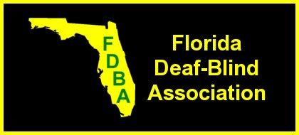For more information, please visit our website: [www.fldeafblind.org](http://www.fldeafblind.org)

Contact information:

Darlene Laibl-Crowe at [dlcrowe@fssp.fldeafblind.org](mailto:dlcrowe@fssp.fldeafblind.org)