Family-to-Family Communities Project (F2FC)
Connecting Families of Individuals with Deaf-Blindness

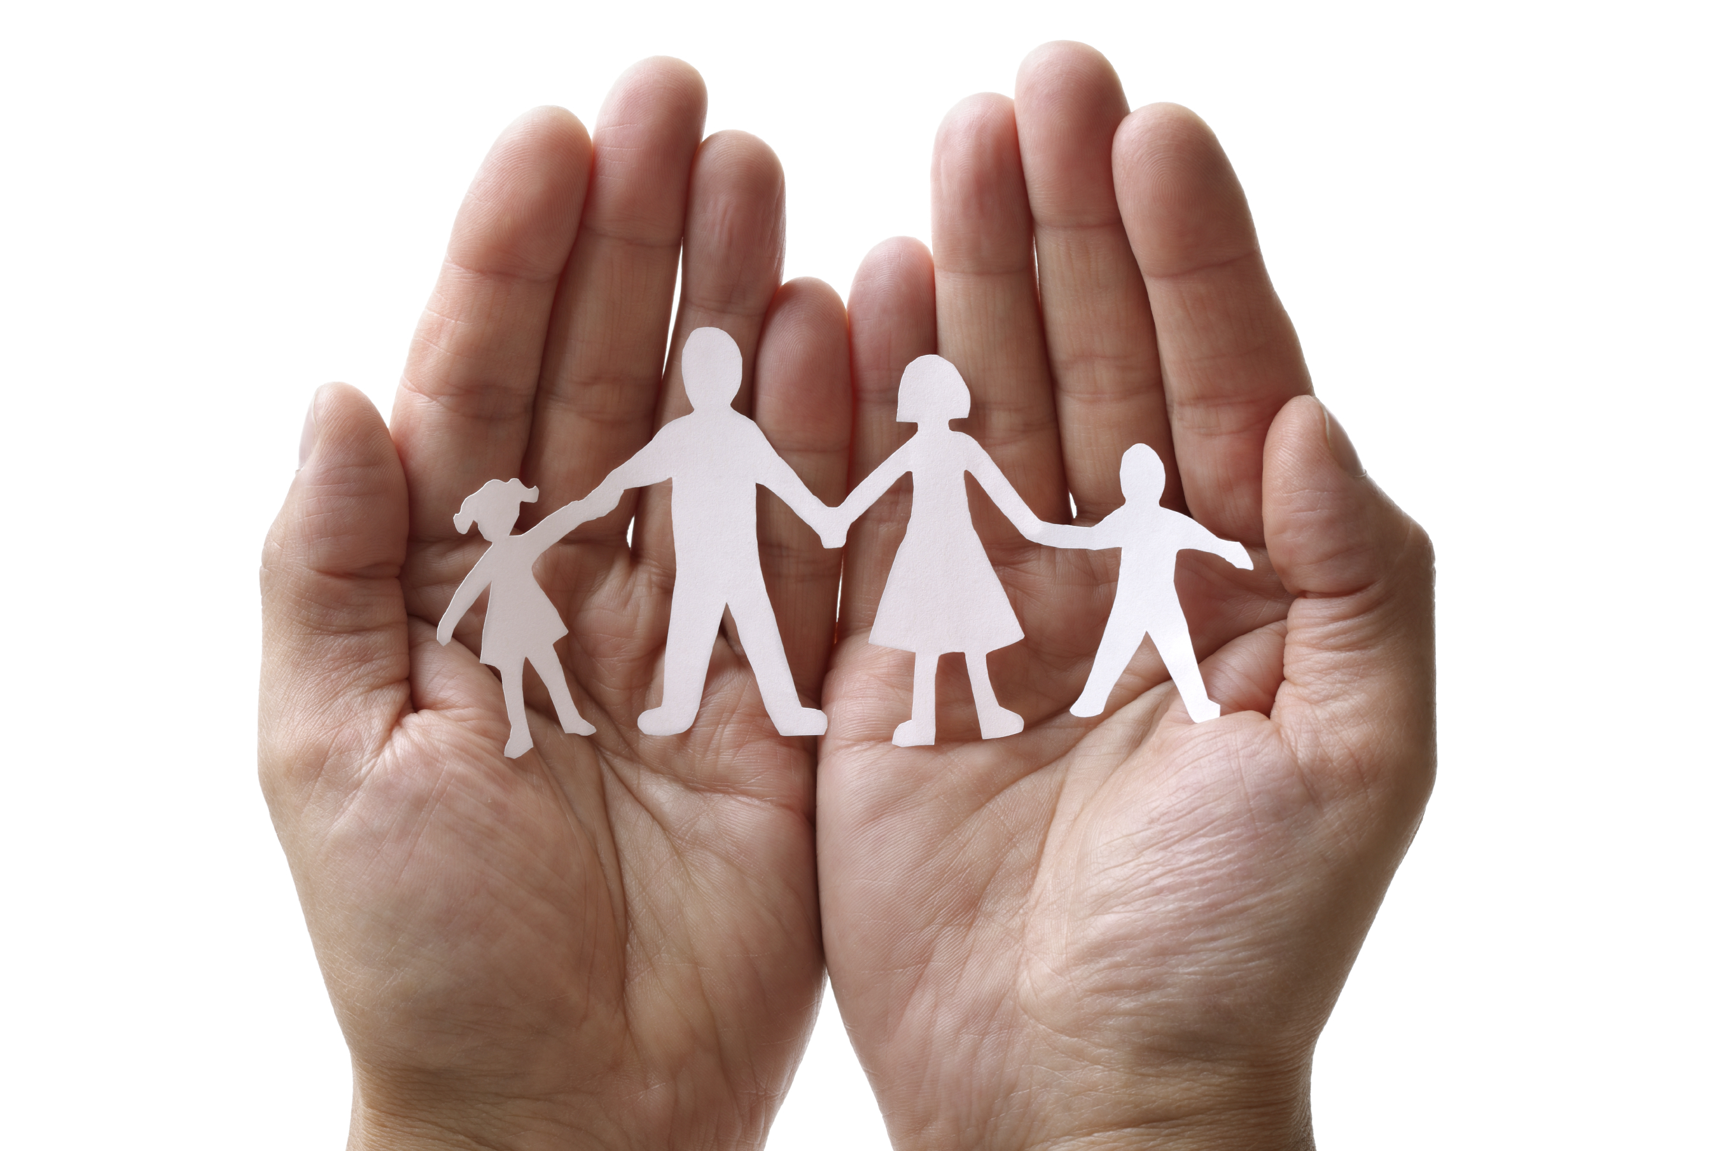
Because deaf-blindness is a rare and diverse disability, families may feel isolated or alone…like there is no one else who understands their experiences.
F2FC offers a unique way for families to connect, share information and resources, offer support to one another, and just talk to someone who “gets it.”
F2FC is open to all families, regardless of the age or diagnosis of your family member, because you share similar challenges and triumphs in the journey of supporting your family member with deaf-blindness.

Family-to-Family Communities Project Format:
- Each F2FC is comprised of 8-10 families with shared commonalities (age of family member, diagnoses, topics of interest, availability, etc.).
- F2FC groups meet once per month for 90 minutes, via phone and/or video conference (group preference).
- These are not drop-in calls; your regular participation is vital to the group.
- Topics are chosen by the group and include a combination of structured conversation and open sharing; categories include communication, family life, accessing resources, and self-care strategies for caregivers.
- Each F2FC is guided by two Facilitators, who have participated in NFADB leadership training.
- F2FC members are encouraged to connect with each other via phone, email, or social media.
- We will add members to current F2FC groups (Families with Young Children, School-Age Children, and Adult Family Members) and also form additional F2FC groups as the project grows.

Family-to-Family Communities Project Timeline:
- Registration is open during June and July 2017.
- During August 2017, F2FC groups will be organized and Facilitators will participate in training.
- F2FC conference calls will begin in September 2017 and continue through May 2018.
- Participants will be asked to complete online surveys (January and May 2018) and will be invited to participate in focus groups (May 2018) in order to share feedback about the F2FC Project.

One F2FC Participant shared that “it was like this little hour of sanity
where you could talk with people who kind of understood where you were…”

Are you interested in joining a Family-to-Family Community??? Find the registration form here:
https://gsap.wufoo.com/forms/f2fc-registration-2017/

Are you interested in learning more about being a F2FC Facilitator???
Contact Carol Darrah, F2FC Coordinator, cdarrah@uga.edu or (706) 542-2433

Contact Carol Darrah or your state deaf-blind project for more information about F2FC.

