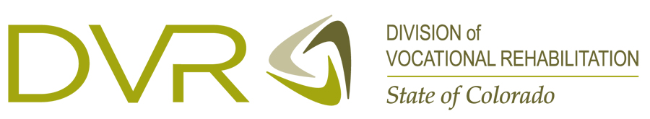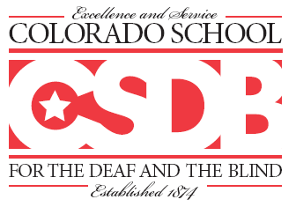
…Learning, Thriving, Leading

Vision Resource Expo
Co-sponsored by CSDB and DVR

When: Thursday, June 19, 2014
9:30 am - 2:30 pm

Where: Gottlieb School Building
Colorado School for the Deaf and the Blind
33 N. Institute Street
Colorado Springs, CO 80903

What: Resources for individuals with vision loss

Directions:
- From I-25 take Bijou St. (Exit 142) and head east (toward downtown)
- Turn right on Nevada and left on Colorado Ave.
- Turn left onto Institute St.
- Turn right into the parking lot at 33 N. Institute St.

Please make interpreting requests by May 19th at the number below:

Have questions or need more specifics, please call DVR at 719-635-3585 ask for
Patty Wagner, Michelle McGowan or Tim Richard

