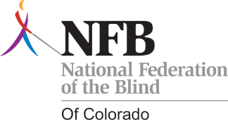

**WE NEED YOUR HELP!**

**Donate items or services as door prizes**

**For the National Federation of the Blind of Colorado’s Greeley Chapter first annual Fund Raising Luncheon.** The National Federation of the Blind of Colorado’s Greeley Chapter would greatly appreciate your support.

**The Luncheon will take place on Saturday, May 17th at the Centennial park Library, located at 2227 23rd Avenue Greeley, Colorado, 80634.**

**Proceeds from the luncheon will be used to support** Braille literacy of blind students, assist newly blinded seniors in living fulfilling lives, and educate parents of blind children.

The National Federation of the Blind Greeley Chapter is a proud, vibrant, and growing chapter of the National federation of the blind of Colorado and the National federation of the blind.

The National Federation of the Blind of Colorado and The National Federation of the Blind are a 501(C3) not-for-profit organization. Our tax identification number is *84-610 7081*.

Your donation will be completely tax deductible and greatly appreciated.