JUNE, 2014
SENIORS IN CHARGE NEWSLETTER
Connecting Blind Seniors Across Colorado

Orlando, Florida is the
Site of 2014 NFB Convention
July 1-6, 2014

The 2014 convention of the National Federation of the Blind will take place in Orlando, Florida, July 1-6, at the Rosen Centre Hotel at 9840 International Drive, Orlando, Florida 32819. Make your room reservation as soon as possible with the Rosen Centre staff only. Call (800) 204-7234. Online registration is now closed. Registration can be made on site in Orlando. The cost is $30 for the convention registration, and $60 for the banquet ticket.

The schedule for the 2014 convention is:
Tuesday, July 1-Seminar Day
Wednesday, July 2-Registration Day
Thursday, July 3-Board Meeting and Division Day
Friday, July 4-Opening Session
Saturday, July 5-Business Session
Sunday, July 6-Banquet Day and Adjournment

On Tuesday there will be seminars for seniors, students, parents of blind children, rehabilitation professionals, individuals interested in technology, and much more. This is a great day to delve into an area of interest. Our own Diane McGeorge heads up the senior seminar so it is always a great time! From there we move into a whirlwind of meetings on anything and everything related to blindness. Our General Sessions kick off with a BANG on Friday, July 4th. General sessions are meetings that everyone attends. These sessions will also be held on Saturday and Sunday. Sunday evening will end with a banquet that includes a riveting address by the President of the National Federation of the Blind, Marc Maurer.

The 2014 room rates for singles, doubles, and twins are, $82; and triples and quads, $88. In addition to the room rates there will be a tax, which at present is 13.5 percent. No charge will be made for children under seventeen in the room with parents as long as no extra bed is requested. The hotel is accepting reservations now. A $95-per-room deposit is required to make a reservation. Fifty percent of the deposit will be refunded if notice is given to the hotel of a reservation cancellation before May 28, 2014. The other 50 percent is not refundable.

⌘ ⌘ ⌘ ⌘ ⌘ ⌘ ⌘ ⌘ ⌘ ⌘
MIRACLES DO HAPPEN
By Duncan Larsen

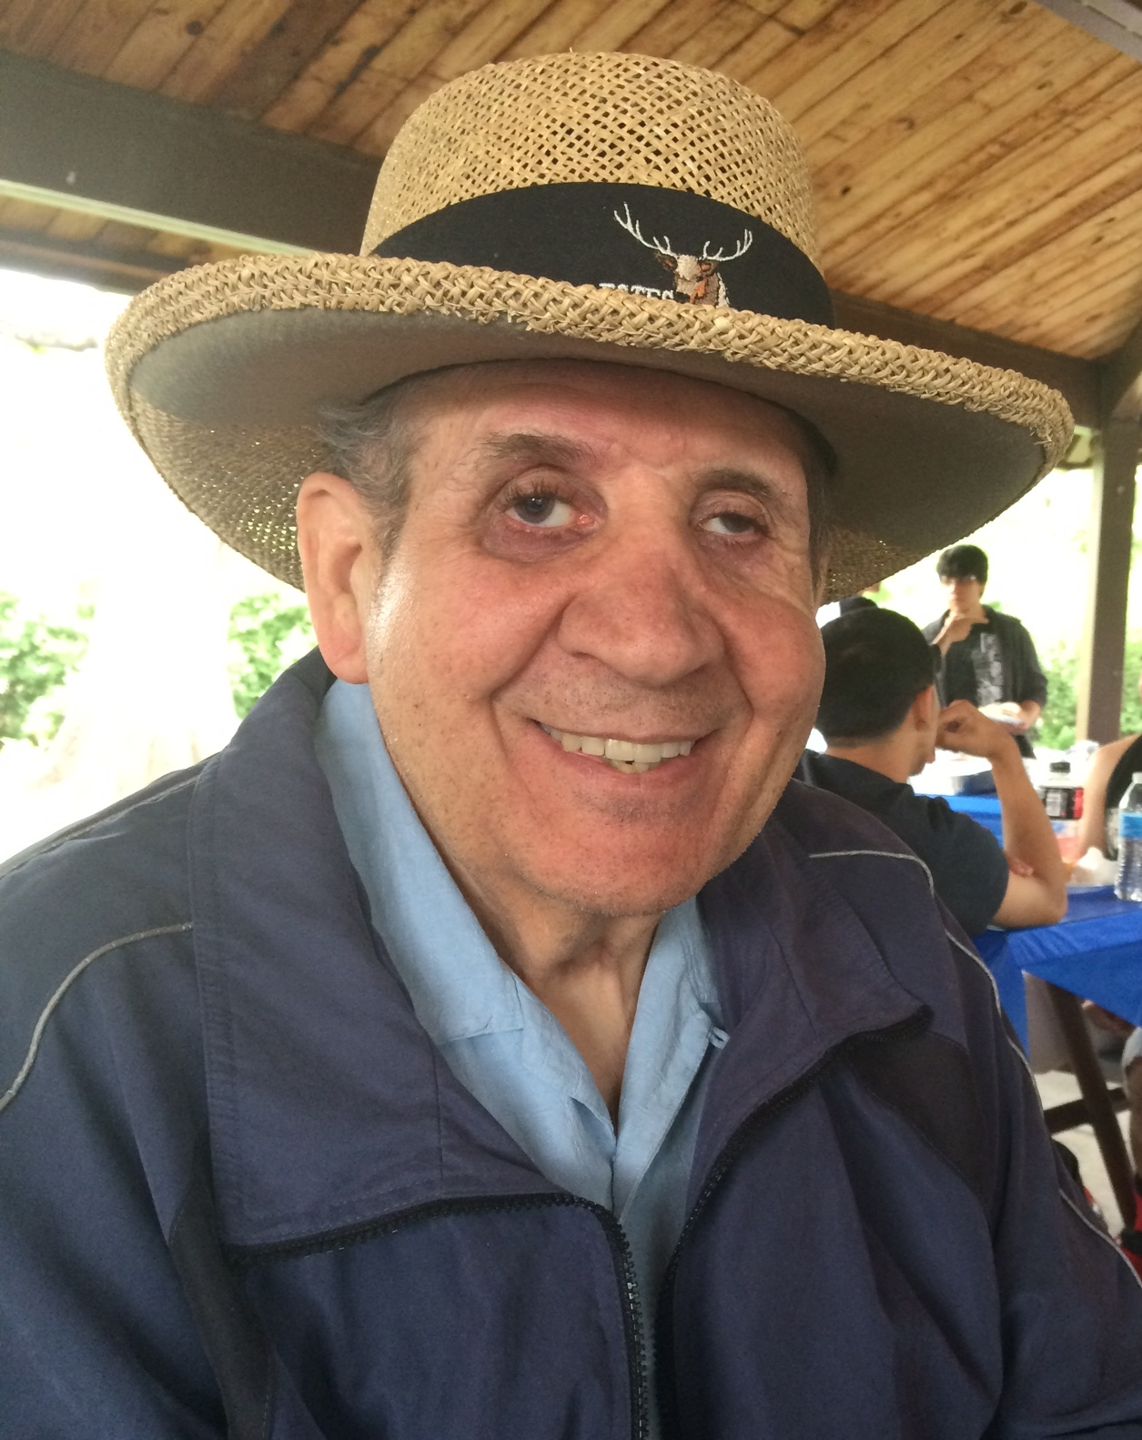
When Rich and Berni Schiavone started to attend the senior groups at the Colorado Center for the Blind a few years ago, we learned that Rich had become blind from a motorcycle accident. What we have come to know since is just how miraculous his recovery from this accident has been.
I recently visited them in their beautiful, warm, and welcoming home in Arvada. There, they told me Rich’s story. Rich served as a fire fighter for the Denver Fire Department for 34 years. He had been very active as a fisherman, skier, golfer and painter. He also loved riding his motorcycle and rode his Harley every chance he got.
Rich retired on July 5, 2004 as a captain with the Denver Fire Department. On June 26, 2007, he was riding his Harley and was hit by a driver who did not see him and turned in front of him. Rich hit the right front bumper of the car, which broke every bone in his face and caused brain trauma. Paramedics called to the scene of the accident knew Rich and responded with extra care. He was immediately taken to St. Anthony Central’s Trauma One Center. Berni believes that this action helped to save his life.
At first, there was so much swelling in his brain that doctors were unable to do any surgery. When they were finally able to operate, it took 15 hours to reconstruct all of the bones in his face and rewire his jaw. At the same time they did brain surgery to repair the dura mater (outer covering of the brain) that was shattered. A tracheostomy and feeding tube were also put in. The following day he had surgery to open up his left leg in 2 places to relieve the pressure from blood clots. Rich was in intensive care in the Trauma Center for five weeks.
Berni, along with their daughter, Keek, and son, Mark, went to the hospital every morning to be with Rich and talk with the doctors. Support also came from Rich’s large Italian family. Berni explained that there were times when as many as 75 people with food would be congregated in the waiting room at St. Anthony’s. Keek had started a CarePages website that gave all of Rich’s friends and family members daily updates on Rich’s progress. She and Mark posted religiously.
Late one night, 15 days following the accident, the doctors stated that they did not think Rich would survive the night due to multi-organ failure or septic shock as they put it. The family was asked to stay at the hospital and permission was given to administer every medication possible to get Rich through this. Keek posted the news on the website at 12:00 midnight, asking for prayers for her father. Most of their friends & family were in bed. But people from all over the world responded, saying that they were praying for Rich. This included congregants from a sister-church in Africa as well as a friend working in China.
Because of the time difference, it was morning in all those places and people were awake. Other friends were “mysteriously” awakened in the middle of the night and were drawn to CarePages and immediately started praying. Rich survived that crucial night and Keek was able to post on the website “I’m crying happy tears as I write this.” The doctors said that Rich had “turned a corner.”
On August 2nd, after five weeks at the Trauma One Center, Rich was transported to a Long Term Acute Care Center, Kindred Hospital. He was still not very responsive at that time. Kindred was able to remove the tracheostomy & heal his open wound from the blood clots with a wound-vac and skin graft. He had several episodes of C-Diff that hindered his progress. After 4 1/2 months at Kindred, the family was told that Rich would be in a nursing home for the rest of his life. Unwilling to accept this grim forecast, the family started calling facilities that they thought could help Rich.
Finally, Mapleton Rehabilitation in Boulder agreed to take Rich on a two-week trial basis (insurance guidelines). He moved there on December 17th and was accepted for the full 2-month stay! Berni said that this was a real turning point in his recovery. Mapleton staff treated Rich like a normal person and were impressed with his progress. They dressed him and had him eat in the dining room. He continued to recover there for 2 months and was then transferred to Western Hills Rehabilitation Center on February 14th where he stayed for another 2 months. Rich later moved to Learning Services on April 22nd, where he stayed for an additional 2 months.
Berni said that at one point friends told her she needed a fundraiser. They organized it and this helped to pay for Learning Services as well as costs associated with making their home wheelchair accessible.
On June 28th, almost exactly a year following his accident, Rich returned home and his extended family was there to welcome and support him. He was wheelchair bound at that point. Through physical and speech therapies, Rich learned to walk and talk again. However, it mostly happened through the incredible support of Rich’s family and Rich’s own determination. One of his doctors said, “He is the strongest man I’ve ever met.” His motivation and determination was amazing.
Three and a half years following his accident, Rich and Berni started attending the Senior Program at the Colorado Center for the Blind. Berni said, “Coming to CCB was one of the best decisions that we ever made. Now we know how to cope with blindness in a positive way.” Rich has used his determination and motivation in order to learn many new skills. These include: skillfully using a white cane along with a support cane, reading Grade One Braille and now working on Grade Two. He has also completed some woodworking projects and has started cooking. He made the recipe that you can find in this newsletter and recommends it. In addition, he has recently gone fishing, taken a golf lesson, gone whitewater rafting, and done zip lining, kayaking and rock climbing!
Berni has this advice for family members: “Never underestimate what a blind person can do because it’s amazing what tools are out there for them to use. Be patient. If you can learn Braille with them, do it. It’s fun!” When I asked Rich for his words of wisdom, he said, “If you are blind, don’t ignore it. Learn how to use a white cane, learn Braille, how to take the bus, and how to take the Light Rail.”
Rich’s story is truly inspiring. Miracles really do happen!

⌘ ⌘ ⌘ ⌘ ⌘ ⌘ ⌘ ⌘ ⌘ ⌘
DID YOU KNOW....

The next NFB State Convention will be held in Denver on
October 30, 31, November 1 & 2 at the Marriott Denver South
in Park Meadows. Please give some serious thought to joining
us this year. More information will be available soon.

⌘ ⌘ ⌘ ⌘ ⌘ ⌘ ⌘ ⌘ ⌘ ⌘
TECH CORNER
By Wayne Marshall

I’d like to start this month’s Tech Corner by acknowledging a couple of seniors that recently graduated from our Senior’s Technology Program. Leonard Ginn, for completing his training on the desktop computer using JAWS and learning Windows, and Judy Hollyhead, who completed her training on the use of the Apple iPad and it’s applications. Well done guys!

As the Senior Program at the Colorado Center for the Blind has grown, so has its Technology Program. In fact, there is currently a waiting list of eager seniors who want to learn more about the various types of technology. Although there’s is a definite learning curve, many seniors are learning to use the Apple iPhone and iPad with the use of “voiceover”, which is Apple’s screen reading program similar to JAWS or Window Eyes. Voice Over allows users to execute many of the phone’s functions with voice commands. Many forms of information can also be accessed with “Siri”, which is Apple’s interactive voice activated search engine.

Many blind seniors who also have a hearing loss and or a hearing aide, have found the iPhone’s accessibility features for hearing loss to be a pretty great feature of the phone and iPad as well. One can find these features by going to Settings, then to General, and then to Accessibility. There you will find the options for Voice Over, Low Vision, and Hearing loss.

Although the iPhone and iPad is not for everyone, it is a great product that provides out-of-the-box accessibility for various needs.

⌘ ⌘ ⌘ ⌘ ⌘ ⌘ ⌘ ⌘ ⌘ ⌘
The Phamaly Raffle

The Phamaly Theater Company is presenting “Joseph and the Amazing Technicolor Dreamcoat” this summer at the Denver Center for the Performing Arts in the Space Theater. The Phamaly Theater Company is made up of actors who all have various disabilities and their programs have been welcomed and enjoyed by many.

The seniors at the Colorado Center for the Blind are having a raffle for 2 tickets to their production on July 20, 2014. At that performance, there will be audio description, information in Braille as well as print, and a sensory tour that takes ticket holders back stage to meet the actors and get their hands on the costumes and props. To learn more about the audio descript performance on July 20th, click the following link or call 303-893-4100.
https://tickets.denvercenter.org/Online/default.asp?doWork::WScontent::loadArticle=Load&BOparam::WScontent::loadArticle::article_id=8E078176-0B83-452D-8A5B-AEFC4ADBCFDA#

The drawing for the 2 free tickets, which were generously donated by the Phamaly Company, will be on July 11th. The tickets for this show are $30 to $36 each. We are selling the raffle tickets for $2 each or 3 tickets for $5. If you are interested in buying some raffle tickets, you can call Estelle at 303-789-7538 for more information.

All proceeds from the raffle will go to the Senior Groups at the Colorado Center for the Blind for their various supplies, and also occasional donations to the Center for their programs to help people facing blindness. Your support is greatly appreciated!

⌘ ⌘ ⌘ ⌘ ⌘ ⌘ ⌘ ⌘ ⌘ ⌘

Save the Date!
Colorado Center for the Blind presents:
MOSAIC
A Showcase of the Arts
Join us at the Center
2233 West Shepperd Ave
Littleton, CO 80120

Friday, September 5, 2014
5:30 pm - 9:30 pm

Headliner Café Americana will be performing a musical combination of Jazz, Bluegrass, Folk and Americana music. The evening will include exhibits of students’ tactile and industrial arts, an array of delicious food, a cash bar, an exciting live auction and surprise entertainment.

Purchase tickets NOW just $30.00
Call Dan Burke (303) 778-1130 x213, email dburke@cocenter.org or visit www.cocenter.org
Personal and corporate sponsorships also available

Proceeds from this event directly support our innovative Youth Services Programs. Your support helps a blind child get a cane, learn to read Braille and understand that blindness is just a characteristic of who they are.

⌘ ⌘ ⌘ ⌘ ⌘ ⌘ ⌘ ⌘ ⌘ ⌘

My Brailler is Sick!

Do you own a Perkins Brailler that doesn’t seem to perform properly? We have a gentleman in Denver who can clean and repair your Brailler for a very reasonable charge. If you live outside of Denver, he may still be able to help you.

For more information, please call Kirk McCall at 303-274-4640.

⌘ ⌘ ⌘ ⌘ ⌘ ⌘ ⌘ ⌘ ⌘ ⌘
We Have Our First Winner!!

In our last issue, we offered a Braille Chocolate Bar to the winner of a drawing made up of individuals who contacted us with suggestions, comments, possible articles or even questions about the newsletter.

The first winner is Phyllis Chavez
CONGRATULATIONS!

As we send out this newsletter, we are continuing our offer. Yes, it is a ploy (but a tasty one at that!) to get you interested and participating in this Senior newsletter! We know all of you have experiences, challenges and successes dealing with vision loss in your lives, and we encourage you to share them with us. You will be helping many others who also want to learn.

Here in Denver, we have some great resources for the blind and visually impaired. Now, with this newsletter, we hope to spread the news that there is help and information available. It all comes from our willingness to share. We can’t do it alone, so we would like to make connections with others in Colorado to help us
..………and, who knows, you may even win a Braille Chocolate Bar!

⌘ ⌘ ⌘ ⌘ ⌘ ⌘ ⌘ ⌘ ⌘ ⌘

Aging Humor
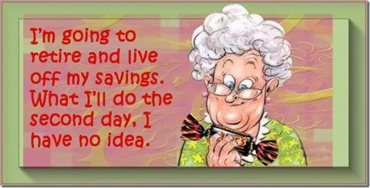

⌘ ⌘ ⌘ ⌘ ⌘ ⌘ ⌘ ⌘ ⌘ ⌘
Book Review

THUNDER DOG
By Michael Hingson

In 2001, Michael Hingson and his guide dog, Roselle, were working on the 78th floor of the North Tower of the World Trade Center when it was attacked. Roselle showed a remarkable ability to stay focused under extreme pressure. The night before, she quivered in fear during a thunderstorm, thus earning the moniker - "thunder dog." However, the next morning she performed beyond any trainer's wildest expectations. She breathed in smoke and noxious fumes. She was, for the most part, without water. She, herself, was blinded in the dust cloud. Yet she continued doing her job until she brought her master back to their home in New Jersey. Through fatigue, panic and unbearable physical conditions, she persevered.

Michael Hingson details their experience as well as significant information about his life as a blind person, and his work with the NFB, which he continues to be involved with.

Even though we realize that Michael and Roselle will survive; the step-by-step account of their journey to safety, as well as the author’s description of the resistance he faced and his successes in his work and life, will keep you engrossed!

⌘ ⌘ ⌘ ⌘ ⌘ ⌘ ⌘ ⌘ ⌘ ⌘
Recipe Box

Pita Pizza

This quick and easy recipe only takes ten minutes to cook and is perfect either as a snack or with a salad for a main dish.

Serves: two

Ingredients
- 2 pita bread rounds
- 4 tablespoons of spaghetti sauce or more if desired
- Garlic Powder to taste
- Dried Oregano (use sparingly)
- Dried Parsley
- Shredded mozzarella cheese
- Sausage, cooked & crumbled or sliced pepperoni
- Any vegetables you have in your fridge, chopped – (examples: mushrooms, peppers, jalapenos, tomatoes, olives, onions)
- Romano cheese, grated

Method
- Preheat oven to 400 degrees
- Place Pita rounds on a baking sheet
- Spoon 2 tablespoons of spaghetti sauce over each pita round.
- Sprinkle with garlic powder to taste
- Sprinkle dried oregano sparingly over both rounds
- Sprinkle dried parsley over both rounds
- Top with mozzarella cheese and your favorite meat & veggie toppings
- Sprinkle Romano cheese on top of everything
- Cook about 10 minutes or until cheese has melted & toppings are heated
- Enjoy!!
⌘ ⌘ ⌘ ⌘ ⌘ ⌘ ⌘ ⌘ ⌘ ⌘

What is a Braille Buddy?
By Estelle Shukert

You have probably heard of Pen Pals, people you can correspond with by mail using a pen to write letters. Well, if you write in Braille you can have Braille Buddies!

I have been studying Braille for over 3 years. I have finished Grade Two, but I really do feel like I am still in second grade! I know that I need to keep using this method of reading and writing if I want to
improve, so I requested Braille correspondents in a letter to the Braille Monitor.

It took over a month before I heard from anyone, and now I have 8 Braille Buddies and one Pen Pal! My Pen Pal and I can still see enough to write, and she doesn’t know Braille – yet! Four of my Braille Buddies are in various states. Four are on the other side of the world! That was a pleasant and very interesting surprise. I not only have new acquaintances, but I’m learning about life in other countries, and I’m getting lots of practice with my Braille!

Have you found ways to help you use and continue to improve your skills as a blind or visually impaired person? Your ideas may help others who are taking a similar journey. We’d be happy to include your story in this newsletter! You are welcome to contact us by mail, phone or on line.

Colorado Center for the Blind
Duncan Larsen
2233 W Shepperd Ave
Littleton CO 80120
(303) 778-1130
dlarsen@cocenter.org

