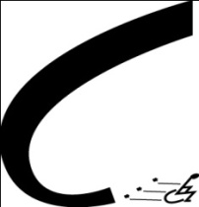
Connections for Independent Living

September/October 2014
“Even if you fall on your face, you’re still moving forward.” –Victor Liam

Hi Everyone:
Fall brings some nice events and new programs to Connections and the Vision after 55 program. Connections is participating in the the Greeley Community Garden Tour September 7, and spreading the word about the Colorado Person First Festival (formerly the Colorado Disability Pride Fest), which takes place on September 13th in Fort Collins. And we really hope you will atttend our annual Consumer Appreciation Day cookout on September 18 at Bittersweet Park. Garden Tour tickets are $10, or you can volunteer to help and get free food—call Erin at Connections for information. See the calendar on this newsletter for info on the NFB Resources Expo and the Area Agency on Aging Diabetes class!

If you or someone you know has a vision impairment and would like to learn to use an iPad or iPhone for communication and daily tasks, please call me! We are forming a Tech Club for a fun learning and sharing experience. Stay tuned for news on the next MagnifEyed Living seminar to be held in early November.
In August the US Bureau of Engraving and Printing announced they would be providing free bill readers to those with vision loss. This news comes at the end of a long battle by advocates such as the American Council of the Blind. Read more about this technology in this newsletter.
Thank you,
Lynda McCullough, Vision After 55 Coordinator
(970) 352-8682, ext 109, email: Lynda@connectionsil.com
What iPads Can Do
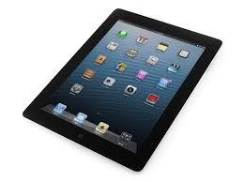
Connections is working closely with the High Plains Library District to teach people with vision impairments how to use the accessibility features of iPads and iPhones. These devices have excellent magnification and/or voiceover features, and there are many apps that can make day to day life easier, such as money or color identifiers, talking GPS you can use while walking, picture-taking features that then identify objects, voice operated note takers, and more. Whether you are just curious or are already using an iPhone and want to use more, this is the group for you.
How do you Identify Money? (excerpted from the Sightseeing Blog, Center for
the Visually Impaired, http://www.cviga.org/sightseeing/.org)
by Empish J. Thomas, Posted on 8/18/2014
One of the most frequently asked questions I get as a blind person is how do you identify your money? Since US paper currency is printed with the same color ink and each denomination has the same shape and texture it is very difficult to determine differences. This challenge reduces the level of financial independence for those with vision loss. It also creates opportunities to be taken advantage of by dishonest people.
It can be hard for me to answer that question about identifying my money because there are multiple ways to do it. As a result, I have strayed away from using paper money and depend more on debit and credit cards but others might feel differently. For a long time now people who are blind and/or visually impaired have had to find a variety of ways to identify their paper printed money. Some have depended on trustworthy sighted people to help determine their one dollar bills from their fives, tens or twenties. After getting assistance from a sighted person, the bills can be folded in different ways to tactually determine the differences between them.
Others have used accessible wallets with multiple slots to place each denomination in. or they might use a device such as a hand-held bill reader for identification. Yet, more recently others have used accessible apps on their iPhone or smartphone to scan and read their cash.

Free Bill Readers for the Blind
But just last month the US Bureau of Engraving and Printing announced that they would be providing free bill readers to those with vision loss. This is great news because it will allow the visually impaired to be more financially independent and have equal access to their paper money. This news comes at the end of a long battle by advocates such as the American Council of the Blind.
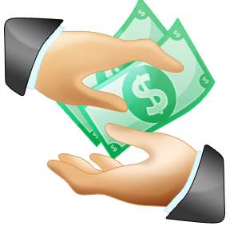
The BEP will process requests in two phases:
The first phase will be a pilot starting on September 2, 2014 in collaboration with the National Library Service for the Blind and Physically Handicapped (NLS). All library patrons can pre-order their readers. This will allow BEAP to test its ordering and distribution processes and better gauge demand.
The second phase will be a national rollout. Any US citizen who is blind or visually impaired will be able to order a bill reader beginning January 2, 2015. Individuals who are not NLS patrons must submit an application, signed by a competent authority who can certify visual impairment.

Event Calendar
September 7, 3:30 to 6:30, Community Garden Tour (Connections location)
September 9 to October 14, Tuesdays 1:30 to 4:30, Greeley Medical Clinic, call (97) 346-6950, ext. 6117
September 13, 10:00 to 2:00, Colorado Person First Festival in Fort Collins (call (970) 416-2023 for information on rides)
September 18, 4:00 to 6:00, Consumer Appreciation Picnic, Bittersweet Park
September 19, 10:30 to 5:00, NFB Resources Expo at Centennial Park Library
September 30, 2:00 to 4:00, Meet the Candidates at Greeley Recreation Center
September 30, 2:00 to 4:00, Meet the Candidates, Greeley Recreation Center

Connections for Independent Living
Free Matter for the Blind or Handicapped
1331 8th Ave.
Greeley, CO 80631

