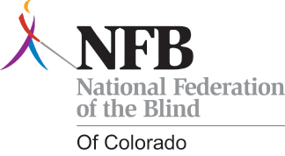

The Third Annual
National Federation of the Blind of Colorado Greeley Chapter
Fund Raising Luncheon
Are you interested in supporting Braille literacy for blind students, assisting newly-blinded seniors with living fulfilling lives, and educating parents of blind children? If so, the Greeley Chapter of the National Federation of the Blind of Colorado's Fund Raising Luncheon is for you. It is being catered and will include a program to fill attendees in on the exciting progress that the National Federation of the Blind of Colorado has made to help improve the lives of Northern Colorado's blind.
When: Saturday June 4, 2016, from 1:00 to 3:00 PM.
Where: Centennial Park Library
2227 23rd Avenue
Greeley, CO 80634
Please RSVP by May 21, 2016.
The tickets are $15 (fifteen dollars) per person, and can be paid with cash or personal check when you RSVP.
To RSVP, please contact Cody Bair, President of the NFB Greeley Chapter. He can be reached at (970)673-6998 or codyjbair@yahoo.com.
We hope to see you there!

