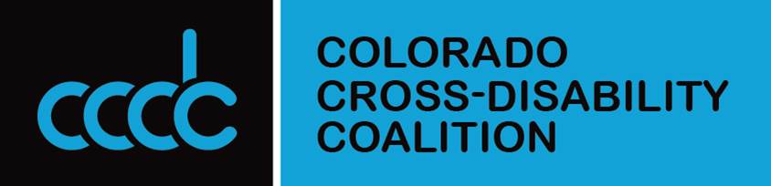

The Premier Disability Rights Advocates in Colorado
_________________________________________________

Summer 2018 Listening Tour
The Colorado Cross-Disability Coalition (CCDC) is taking Advocacy on the Road
this summer and we want you to join us in a Colorado Community near you!!

If you need accommodations such as an interpreter or any other accommodation you must contact Karyn as soon as possible. Snacks will be provided; please RSVP so we can get accurate counts.

WHEN:  August 14, 2018  3:00 p.m. – 5:00 p.m. | WHERE:  Lincoln Park Library  1012 11th St.  Greeley, CO 80631 | RSVP CONTACT:  Karyn ReNae Anderson kranderson@ccdconline.org  (970) 393-0170
The Colorado Cross-Disability Coalition (CCDC); The largest most experienced and trusted statewide disability rights organization in Colorado is conducting a Summer 2018 Listening Tour. It’s taking place in communities around the state and CCDC wants to hear from you!
During this tour, CCDC Executive Director Julie Reiskin will be available to provide the most up to date, accurate information on what has and has not changed at the Federal level regarding disability policy, what has and has not changed at the state level, and how you can make sure that your voice is heard.
We want to hear from people with disabilities (PWD) and our allies around the state about the most common issues that affect them in their communities. When possible, we want to help find possible solutions. CCDC will be revising Its strategic plan in 2019 and we want to ensure we focus on those issues most important to Coloradans with Disabilities.
In addition, CCDC will soon introduce new partnerships that are being created: To unify the voice of Colorado's disability community and elect public officials who support Medicaid and all PWD in our great state. This will help us shape public policy in the future and make sure that PWD are included in all levels of government. ‬‬
___________________________________________________

