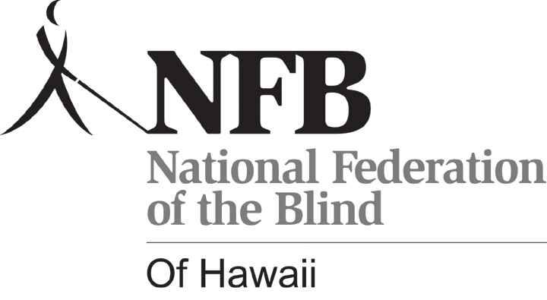
July 29, 2026

NATIONAL FEDERATION OF THE BLIND OF HAWAI‘I
SCHOLARSHIP APPLICATION
Application year 2009

Applicant’s Full Name:
Home Address:
Home Phone Number:
School Name and Address:
Date of Birth:

EDUCATIONAL BACKGROUND: Please list your educational background, beginning with the most current school attended. Use a separate sheet if necessary. Please include your high school or college transcripts with your application.

School & Address | Major | Dates Attended | Cumulative GPA | Degree

Please attach a letter to your application that addresses the following questions.
- What degree are you pursuing, and what are your long-term career goals?
- What community involvement / extracurricular activities are you involved in?
- What skills and devices do you use in your daily life as a blind person?
- Provide any additional stories/incidents that you feel are relevant to your experiences as an independent blind person.
- How will this scholarship help you?
te: Documentation that indicates that you are legally blind must be included with your application. Documentation from your physician, Vocational Rehabilitation agency, or Department of Education, Special Education section is acceptable.

______________________ _________________
Applicant’s Signature Date

Please mail completed application with supporting documentation, letters of recommendation, and transcripts to:

NFB of Hawai‘i Scholarship Committee
c/o DDr. Ann Lemke
47-370 Hui Iwa St.
Apt. B
Kaneohe, HI96744

