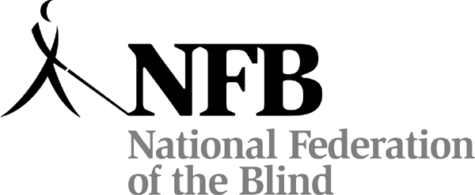

For Blind High School Seniors through Grad School Students

ARE YOU A LEGALLY BLIND STUDENT?
Go to:
www.hawaii.nfb.org/scholarships
for the
NATIONAL FEDERATION OF THE BLIND OF HAWAII
2011 SCHOLARSHIP PROGRAM Application

To Apply: Read the rules and the Submission Checklist, complete the official 2011 Scholarship Application Form online or submit a print form, send all required documents before the deadline to NFB of Hawaii PO Box 4482,Honolulu, HI 96812 and complete one telephone interview with our representative.

Questions to: NFBH Scholarship Committee Chairperson, Betty Bell or Nani Fife
Office: (808) 595-6123; 1 866 595-6123 E-mail: nanifife@aol.com Deadline: October 8, 2011 by

or postmarked by October 5, 2010

Deadline: All documentation must be received or postmarked
by March 31, 2010.

