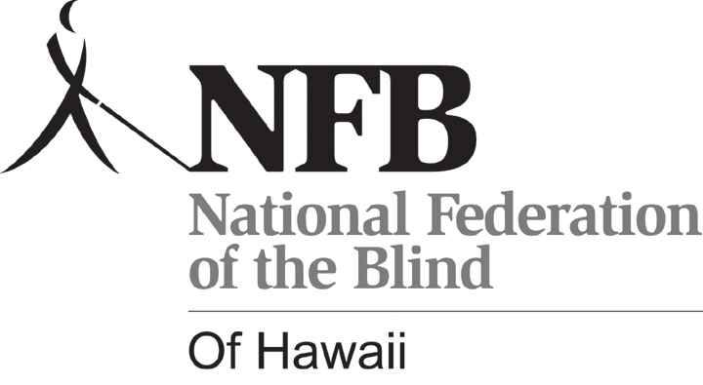 P. O. Box 4482
Honolulu, HI 96812
Phone: (808) 595-6123

June 28, 2013

Re: Door Prize Donations

Aloha Friends and Supporters of the Blind:

We are pleased to announce that the annual convention of the National Federation of the Blind of Hawaii (NFBH) will take place on September 14 & 15, 2013 at the Waikiki Elks Lodge in Honolulu. NFBH is a State Affiliate of the National Federation of the Blind, which is the oldest and largest organization of the blind in our country with the widest and most influential voice in the affairs of the blind. Our Hawaii Affiliate is honored to be a very vital and dedicated part of the organized blind movement both locally and nationally.

Our mission is to provide for security, equality, and opportunity for all blind persons, especially in the areas of social, political, and economic integration into community and society, through public education and self-advocacy. Some of the services we offer include: information referral and access, technical and moral support, and employment projects operated in partnership with the U.S. Department of Labor.

Each year, our convention provides an opportunity for the blind and visually impaired in our state to come together for a common cause. Much outreach, networking, sharing, and educating of self and others takes place. Public service and other resources for the blind are presented, ideas are exchanged, and plans and policies for the coming year are formulated.

During our program, we draw for a number of door prizes, which helps to make our convention more fun, interesting, and generally more successful. We hope that you, as one of our friends and supporters in the business community, will assist us, through your company, by providing items and/or gift certificates for this purpose.

Any donations will be deeply appreciated and tax deductible as we are a tax-exempt, non-profit organization. If you need any additional information, please feel free to contact me at the phone number below.

Thanks in advance for your time and kind consideration.

Respectfully,

Nani Fife
President, NFB of Hawaii
(808) 391-1214

Sent by: Virgil Stinnett, VP NFB-H
(808) 722-4243

