***John T Hays***

*Post Office Box 1855*

*Honolulu HI 96805-1855*

(808) 754-0780

[johnthaysiii@gmail.com](mailto:johnthaysiii@gmail.com)

Honolulu, March 29, 2016

City and County of Honolulu

Honolulu Hale

530 South King Street

Honolulu, HI 96813

**HAND DELIVERED**

Dear Sirs:

I am addressing you as a 32½-year Hawai‘i resident, and, as a person who is legally and functionally blind, I am also an active member of the Honolulu Chapter of the National Federation of the Blind. In the past six months, I have been hospitalized, operated on, and have undergone medical treatments at several Honolulu locations. During this period, Mrs. Hays and I have discovered the courtesy, efficiency, flexibility, and reasonable cost of the Uber transportation system.

As you may have read, the Founding Fathers of this country based our fledgling nation on the rule of law and a free market economy. More than 95% of our restrictions, regulations and taxes today have been inventions of the past 100 years. And present day politicians increasingly seem to want to perpetuate the decorative icing while forgetting about the substance of the cake. Please recognize that Uber provides a useful service at a reasonable price, and creates new jobs for Hawai‘i residents, while maintaining healthy competition. To attempt to kill this new business, transportation company and job source would fly in the face of our country’s traditions and the best interests of her population. Do not let that happen!

Aloha,

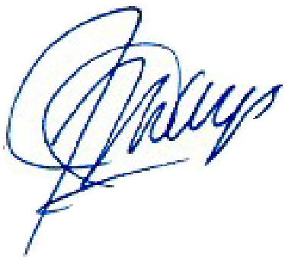

John T. Hays