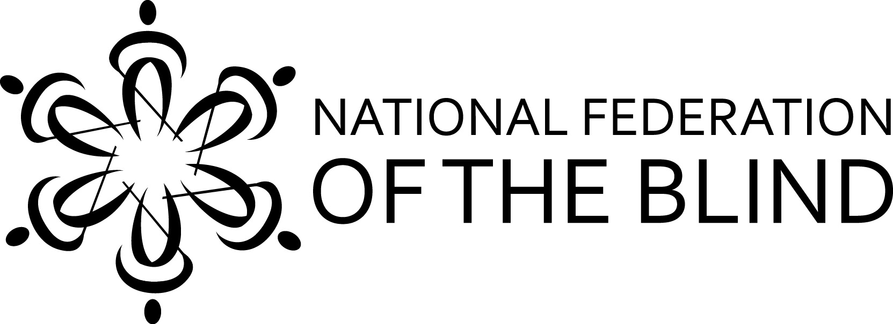
You are cordially invited to the
National Federation of the Blind of Hawaii
2017 Annual State Convention

"Kupuna to Keiki - Full Circle of Love"

NFB National Representative: Joe Ruffalo, Bloomfield, New Jersey

WHEN: Friday September 29 – Sunday, October 1, 2017

Welcome BBQ: Friday: 6:00 pm
Tropic Seas Seawall, 2943 Kalakaua Ave.
Bus Routes: 19, 20, 22
Buses stop at Outrigger and Elks clubs. 2nd driveway to the left is Tropic Seas Inc.

General Convention: Saturday: Registration 8:00 am
Program: 9:00 am - 5:00 pm
Evening Social: 6:00 pm, location TBA

Exhibits, Presenters, Awards, Scholarships, Networking and More!

General Convention: Sunday: Registration 8:00 am
Program: 9:00 am - 12:30 pm

WHERE: Ho'opono Auditorium. 1901 Bachelot St. Honolulu, HI. 96817

Please Register!
Registration: $75 Pre-Registration and at the door

Includes: Saturday, continental breakfast and lunch; and Sunday, continental breakfast

Remit checks, registration and mail to: NFB Hawaii, P.O. Box 4482, Honolulu HI 96812

For Further Information, call: Katie Keim (808) 722-4242
Email: 808keim@gmail.com
NFBH Voicemail: (808) 595-6123
Toll Free Neighbor Islands: (866) 595-6123
Visit: hawaii.nfb.org

