Knights of the Blind

Presents Blind Socceroao
Date: January 13, 2018
Where: Manoa Gym at Manoa District Park
Time: 9am-11am.- Soccer
11am-12:15pm - snacks/lunch

Come one come ALL!

Bring your iron clad sneakers, a jug of water and your honor, bravery and courage!
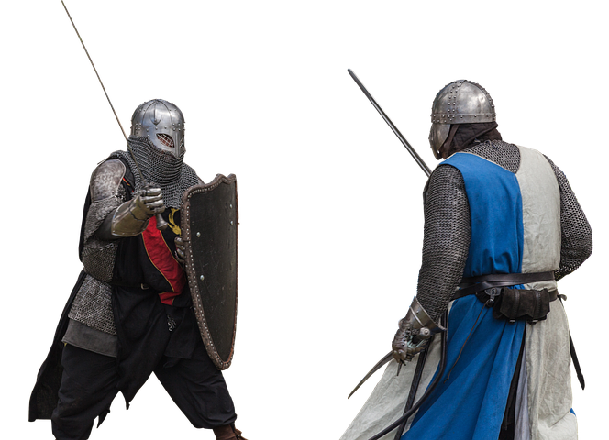
Come out to learn the basic skills of soccer and kick around a beeping soccer ball . Open to all ages, blind, vision impaired and sighted. Once you’ve kick around the ball, GAME DAY will be followed in the near future to test your skills. Be BRAVE and conjure up all your COURAGE to come out for an exciting and fun filled day!!!
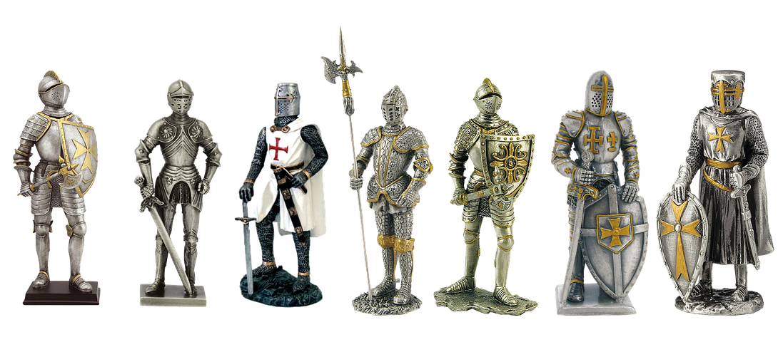
Who’ll dare take on this Challenge?
Sign up before January 6, 2018.
Contact: Sharon Ige @ 808.892.9477
Lili Shintani @ 408.431.9828/ lili@alan-shintani.com
email Charmaine Birchard @ birchardc@gmail.com

