**TheHandi-VanO**

Rider’s Guide

Department of Transportation Services

City and County of Honolulu

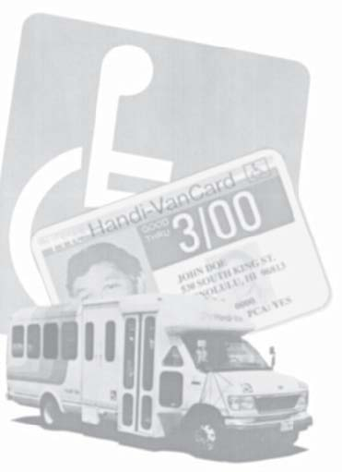

Revised January 2017

If you would like a copy of this Guide in an accessible format

(i.e. large print, audio or

Word document file),

please call (808) 768-8300.

# TheHandi-Van Phone Numbers

**TEL #s**

|  |
| --- |
| **TheHandi-Van** |
| **New Reservations or Reservation Changes** |
| *(Daily, 8:00 a.m. – 5:00 p.m.)* |
| **Cancellations** |
| *(Daily, 24 hours)* |
| **Late Van Inquiries** |
| *(Daily, 4:00 a.m. – 12:00 midnight)* |
| **Lost & Found** |
| *(Monday – Friday, 7:30 a.m. – 4:00 p.m.)* |
|  |
| **456‑5555 (voice) • 454‑5045 (TTY)** |
|  |
| **Fare Ticket Purchases** |
| TheBus Pass Office |
| *(Monday – Friday, 7:30 a.m. – 3:30 p.m.)* |
|  |
| **848‑4444 (voice) • 848‑4500 (TTY)** |
|  |
| **Client Information Changes** |
| TheHandi-Van Eligibility Center[[1]](#footnote-1)\* |
| *(Monday – Friday, 8:00 a.m. – 5:00 p.m.)* |
|  |
| **538-0033** |
|  |
| **Customer Service Comments** |
| Oahu Transit Services, Inc. |
| *(Monday – Friday, 7:30 a.m. – 4:00 p.m.)* |
|  |
| **456‑5555 (voice) • 454‑5045 (TTY)** |
| Department of Transportation Services |
| *(Monday – Friday, 7:45 a.m. – 4:30 p.m.)* |
|  |
| **768-8300** |

This Rider’s Guide is intended to provide eligible riders, caregivers and agencies with a handy reference to using TheHandi-Van.

The Rider’s Guide does not replace City, State, and Federal laws and regulations that govern operations of TheHandi-Van.

If you wish to obtain a copy of the City Ordinance Section 13 Article 4 – Special Transit (Paratransit) Service, please contact:

Department of Transportation Services

City and County of Honolulu

Website: <http://handi-van.honolulu.gov>

Email: handivan@honolulu.gov

Phone: 768‑8300.

# Table of Contents

Table of Contents

**TOC**

TheHandi-Van Phone Numbers 1

Table of Contents 3

Quick Reference 5

Registration 5

Fares 5

Hours of Operation and Service Area 6

Making a Reservation 6

Getting Ready for Your Pickup 6

Remember… 7

Eligibility 9

Registration 11

Hours of Operation and Service Area 12

Fares 14

Making a Reservation 16

Reserving Multiple Trips 19

Remember… 19

Other Things to Know When Making a Reservation 21

Cancellations 24

No-Shows 25

A “no-show” occurs when: 25

“Where do I wait for my ride?” 26

When TheHandi-Van Arrives 29

Travel Tips and Courtesy Suggestions 31

**TOC**

Help Us Serve You Better 32

Supplemental Taxis 32

Companions & Personal Care Attendants 33

Companions 33

Personal Care Attendants 34

Boarding with a Wheelchair and Other Mobility Devices 35

Scooters 37

Other Aids 37

The Lift 37

Safety Belts 38

Service Animals 39

Pets, Packages and Children 40

Pets 40

Packages 40

Children 41

Out-of-Town Visitors 42

TheHandi-Van Operators 43

Rules for Operators 43

Lost and Found 46

Prohibited Acts and Misconduct 47

Suspension of Service 48

MC900293228[1]

|  |  |
| --- | --- |
| j0293238 | Quick Reference |

Quick Reference briefly describes how to ride TheHandi-Van. Each step references a specific page for more information about that section. See *Page 1* for important phone numbers.

**QUICK REFERENCE**

## Registration

*(Page 11)*

This Rider’s Guide was mailed to you with a letter stating that you have been determined to be paratransit eligible. Please use the Guide as a handy reference for using TheHandi-Van service.

## Fares

*(Page 14)*

The cost for a trip on TheHandi-Van is $2.00 for each boarding (excluding required transfers).

## Hours of Operation and Service Area

*(Page 12)*

TheHandi-Van service is available in most areas Mondays through Sundays, from about 4:00 a.m. through 1:00 a.m., and 24 hours a day in areas located within three-fourths (¾) of a mile of TheBus Routes 2 and 40.

**QUICK REFERENCE**

## Making a Reservation

*(Page**16)*

Call 456‑5555 (voice) or 454‑5045 (TTY) from 8:00 a.m. to 5:00 p.m. daily to schedule a trip. Starting in February 2016 reservations will be accepted from one (1) to three (3) days in advance.

## Getting Ready for Your Pickup

TheHandi-Van is an origin-to-destination shared ride program. Please choose pickup points that are in accessible areas, generally curbside and adjacent to public streets and roadways, unless additional assistance beyond the curb has been previously arranged with TheHandi-Van.

“TheHandi-Van is not an emergency or taxi service.”

**QUICK REFERENCE**

## Remember…

***TheHandi-Van is not an emergency or taxi service. You will be sharing a ride with other TheHandi-Van passengers.***

***THEHANDI-VAN OFFERS SERVICE BEYOND THE CURB WHEN NEEDED (ORIGIN-TO-DESTINATION, OR ENHANCED SERVICE).***



## Remember…

TheHandi-Van provides standard curb-to-curb service as well as additional assistance door-to-door to riders who, due to their disabilities, need assistance beyond the curb. Door-to-door service means Operators will provide assistance to and from the vehicle and the door of the establishment if needed by the rider; however, Operators cannot enter buildings nor do they assume the role of a Personal Care Attendant (PCA). We recommend that riders provide advanced notice at the time of trip reservation if door-to-door service is needed to allot extra time for loading/unloading.

**Reasonable accommodations/modifications** in policies, practices, or procedures may be requested to ensure that TheHandi-Van services are accessible to individuals with disabilities by calling the Customer Service at 456‑5555 (voice), or 454‑5045 (TTY).  Persons who are not granted requested accommodations/modifications have the right to file a complaint and to appeal the decision.

In accordance with the guidelines issued by the US Department of Transportation, all eligible riders should understand that TheHandi-Van’s offering of enhanced service beyond the curb when needed bypassengers is not an unlimited right. That is, TheHandi-Van is not required to take actions to accommodate individual passenger’s needs that would fundamentally alter the nature of its paratransit services, create a direct threat to safety or security, or are not necessary for a rider to use   
TheHandi-Van. MC900293228[1]

**QUICK REFERENCE**

|  |  |
| --- | --- |
| j0293238 | Eligibility |

All TheHandi-Van cardholders have been certified as being ADA paratransit eligible.

**ELIGIBILITY**

In order to be certified as ADA paratransit eligible for TheHandi-Van service, an individual must meet one of the following criteria:

1. Unable, because of a disability, to board, ride and/or get off a lift- or ramp-equipped bus by themselves. This includes persons who are unable to “navigate” TheBus system without the assistance of another person.

2. Able to independently board, ride and exit an accessible lift- or ramp-equipped TheBus, but an accessible lift- or ramp-equipped bus has not been assigned to the route used by the individual, or TheBus lift cannot be deployed at the person’s stop;

3. Unable to travel to or from a bus stop because of a disability;

4. ADA paratransit eligible visitors from outside Oahu. After registering with TheHandi-Van Eligibility Center, visitors will be eligible for paratransit trips for up to twenty one (21) days per three hundred sixty five (365) day period. MC900293228[1]

**ELIGIBILITY**

***Note:***

***Age is* not *a qualifying factor for receiving paratransit eligibility.***

|  |  |
| --- | --- |
| j0293238 | Registration |

All eligible riders must carry a TheHandi-Van Photo Identification Card when they ride TheHandi-Van.

When your current TheHandi-Van card is about to expire, and if you have taken a ride on TheHandi-Van at least one (1) time during the preceding calendar year, you will receive a reminder notification in the mail that you need to re-apply for TheHandi-Van eligibility if you wish to continue using the service.

**REGISTRATION**

Please contact TheHandi-Van Eligibility Center at 538-0033 if there is any change in your condition that may affect your ability to use TheHandi-Van, such as a new wheelchair or other mobility aid. MC900293228[1]

|  |  |
| --- | --- |
| j0293238 | Hours of Operation and Service Area |
|  |

**Mondays through Sundays**

TheHandi-Van service is generally available throughout Oahu, Mondays through Sundays, from about 4:00 a.m. through 1:00 a.m.

All-day-all-night service (24 hours per day) is available in areas located within three-fourths (¾) of a mile of TheBus Routes 2 and 40 (from Makaha, along Farrington, Kamehameha and Nimitz Highways to Ala Moana Center; and from Liliha, along South King Street, Kuhio Avenue and Kalakaua Avenue to Kapiolani Park). Your Reservationist can tell you if TheHandi-Van ride you need falls within an area that receives twenty-four (24)-hour service.

**OPERATION HOURS**

**Holidays**

MCj03892780000[1]If your regularly scheduled ride falls on any of the holidays listed below, you MUST call to schedule it. **Regularly scheduled rides that fall on a holiday are automatically canceled**. Please call 456‑5555 (voice) or 454‑5045 (TTY) to schedule your holiday ride.

**Holiday rides must be scheduled on:**

* New Year’s Day
* Martin Luther King Jr. Day
* MCj03915480000[1]President’s Day
* Prince Kuhio Day
* Good Friday
* Memorial Day
* King Kamehameha Day
* Independence Day
* Admissions Day

**OPERATION HOURS**

* Labor Day
* Veteran’s Day
* General Election Day
* Thanksgiving Day and
* Christmas Day MC900293228[1]

|  |  |
| --- | --- |
| j0293238 | Fares |

Every TheHandi-Van Cardholder and Companion riding TheHandi-Van shall pay a fare of $2.00 per person per one-way passenger trip.

j0329596A Personal Care Attendant (PCA) shall pay no fare at any time when accompanying a TheHandi-Van cardholder. See   
*Page 34* for more information on   
PCAs.

No fare is required for   
Service Animals. See   
*Page 39* for more   
information on Service   
Animals.

Be prepared to pay the exact fare. Operators do not carry change, and are not allowed to search purses, pockets, backpacks, or other personal items for a customer’s fare.

**FARES**

If you wish to use fare tickets, they may be purchased from TheBus Pass Office at the Kalihi Transit Center at 611 Middle Street, at the corner of Middle Street and Kamehameha Highway in Honolulu. Tickets are sold for $2.00 each. Customers may purchase directly from TheBus Pass Office or by mail. TheBus Pass Office accepts cash, checks, official purchase orders, or money orders payable to TheBus. Credit cards are not accepted.

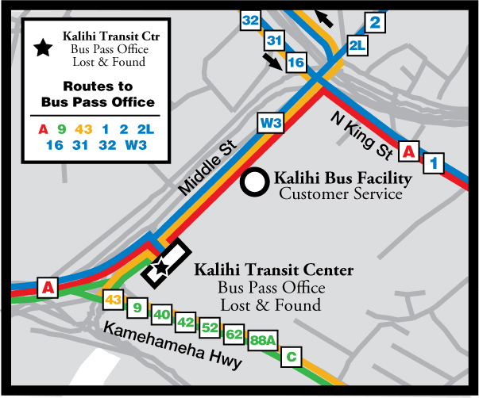You may ride the fixed route, TheBus, for a reduced fare of $1.00 when you show your TheHandi-Van card to the bus driver. MC900293228[1]

**FARES**

|  |  |
| --- | --- |
| j0293238 **MAKING RESERVATION** | Making a Reservation |

Contact a Reservationist at 456‑5555 (voice), or 454‑5045 (TTY). These are the only numbers to call when you wish to arrange a ride with our service.

If you need information instead of a ride, please call Customer Service at 456‑5555 (voice) or 454‑5045 (TTY). Office hours are Monday through Friday from 7:30 a.m. to 4:00 p.m.

Starting February 2016, reservations will be accepted from one (1) to three (3) days before your trip. **Same-day reservations are allowable only on a space available basis**.

**Please be patient.** If you hear a recorded message, stay on the line. **Do Not Hang Up!** Your call will be answered in the order it was received.

MCBS01829_0000[1]The Reservationist will guide you through the process of reserving your ride. Please be prepared to provide the following information:

**MAKING RESERVATION**

1. Your name.

MCj03971720000[1]2. The date and day of the week you need a ride.

3. (a) The time you wish to be picked up OR

(b) An appointment time if you wish to have us schedule your drop-off time.

Add extra time in case you need to be dropped off a few minutes earlier than your appointment time (i.e. prep for surgery, additional time needed to navigate the building, etc.)

4. The address from which you want to be picked up and a phone number where you can be reached.

If your pickup location is difficult to find, be sure to let the Reservationist know this and provide precise directions to your pickup location.

5. The address to which you are going and the phone number, if you know it.

6. The time you will be ready for your return trip. Sometimes it is difficult to know ahead of time exactly when you will be ready for your return trip, but please schedule the trip time as accurately as possible.

If you will be going to a doctor’s office, ask the doctor or a staff member how long your appointment will take. This will help the Reservationist arrange your return ride pickup time.

**MAKING RESERVATION**

j01563857. If you cannot be dropped off earlier than a certain time, let the Reservationist know this.

8. The form of payment you will be using (cash or ticket).

9. If you use a mobility aid, such as a wheelchair, extra large wheelchair (*see Page 35*), walker, or scooter, or if you will need to use the lift.

10. If a Personal Care Attendant (PCA) or Companion(s) will be riding with you.

**MAKING RESERVATION**

11. If a Service Animal will be riding with you.

12. Any other information you feel we should know to safely and comfortably transport you.

## Reserving Multiple Trips

Riders may need to go to several places in one day: From home to the doctor’s office, to a hair appointment, to the library, and then back home again.

Riders who require multiple trips must schedule a separate trip for each pickup location to each drop-off destination. Please be ready to provide all information necessary to enable the Reservationist to accommodate your TheHandi-Van needs.

## Remember…

* All trips taken on TheHandi-Van are important. Priorities are never assigned based on the purpose of a rider’s trip.
* TheHandi-Van is a **shared-ride** origin-to-destination service. The van may stop to let other customers on or off before you get to your destination.
* MCj02921140000[1]Also, please be aware of the opening and closing times of the building or office to which you are going, so you won’t be left outside if you are dropped off early or have scheduled a late return.

**MAKING RESERVATION**

* Trip changes after boarding the vehicle are not allowed. You must go to the destination stated in your reservation.
* If you don’t have a PCA and need personal assistance to and from TheHandi-Van vehicle, it is your responsibility to make these arrangements.
* For complaints, please call Customer Service at 456-5555 (voice) or 454-5045 (TTY) instead of complaining to the Operator to avoid unnecessary delays in your trip and other riders sharing the van.

**MAKING RESERVATION**

**MCPE03039_0000[1]**

## Other Things to Know When Making a Reservation

✓ Allow enough time for your appointment to be finished so you won’t be charged with a “no-show” on the return trip. If you’re not sure when your appointment will end, we can put you on “will call,” and you may call when you’re ready to be picked up. Your return trip will be worked in with the next available van.

✓ The Reservationist may negotiate a pickup time that is up to sixty (60) minutes before or after your requested pickup time.

✓ If you are reserving a ride for a specific appointment time, be sure to mention it to the Reservationist so it can be considered when assisting with your reservation. Failure to mention your appointment time will cause the Reservationist to assume you are requesting a pickup time, and may provide you a time that will not get you to your destination in time.

*Example*

**MAKING RESERVATION**

* You request to be picked up at   
  10:15 a.m. but you actually have a doctor’s appointment at 11:15 a.m. The Reservationist may advise you that the available pickup times are 9:10 a.m. or 11:09 a.m. (within 60 minutes before or after requested pickup time)
* If you mention that your appointment time is at 11:15 a.m., the Reservationist can then provide you an available time going to that destination at the time of reservation that already considers your travel time.

✓ You can expect the van to pick you up within thirty (30) minutes of your scheduled pickup time. We refer to this thirty (30) minutes as your “**pickup window**.”

*Example*

**MAKING RESERVATION**

* You request to be picked up at   
  3:30 p.m. The Reservationist may tell you that you can be scheduled for a 3:20 p.m. pickup. If you agree, then your pickup time will be 3:20 p.m.
* Since your pickup time is 3:20 p.m., the Reservationist will then tell you the van will arrive between   
  3:20 p.m. and 3:50 p.m. That is your “pickup window.”

✓ Please be ready by the earliest time in the “pickup window.” If the van has not arrived within thirty (30) minutes of the scheduled pickup time, please call 456‑5555 (voice) or 454‑5045 (TTY) to report a late van and to find out when your van will arrive.

Keep in mind that unexpected delays can happen because of such things as traffic jams, road construction, or bad weather.

✓ Operators will wait up to five (5) minutes after the scheduled pickup time, or five (5) minutes after they arrive if they arrive later than the scheduled pickup time, and then leave.

## Cancellations

**MAKING RESERVATION**

If you must cancel a trip, please call the Cancellation line at 456‑5555 (voice) or 454‑5045 (TTY) as soon as you know that a trip is not needed.

Cancellations should be made at least two (2) hours prior to your scheduled pickup time.

If your trip is not canceled at least two (2) hours before the scheduled pickup time, you will be considered a “no-show.”

***MCj03892780000[1]***

***Please cancel all trips not needed even if they do not meet the 2-hour cancellation policy.***

## No-Shows

**MAKING RESERVATION**

MCj03243540000[1]When a rider schedules a trip and fails to use TheHandi-Van without proper cancellation, serious transportation and scheduling problems can result for TheHandi-Van and its riders.

It is important that trips are not “wasted” to ensure that all riders can enjoy a convenient and comfortable ride.

Failing to appear for a scheduled trip without proper notification is considered a “no-show.”

## A “no-show” occurs when:

✓ You are not at the requested pickup address and the Operator cannot locate you; or

✓ You are at the address where you requested to be picked up, but you are not ready to board the van within five (5) minutes of the arrival of an on-time van and the van has to depart; or

✓ You have not called to cancel your trip at least two (2) hours prior to pickup to allow for rerouting of the van to another location.

**MAKING RESERVATION**

***MCj03892780000[1]***

***NOTE: Riders who have repeated “no-shows” may be suspended from TheHandi-Van service.***

## “Where do I wait for my ride?”

TheHandi-Van is an origin-to-destination**,** shared-ride service that complements TheBus system.

* You should wait at the sidewalk or at another safe waiting area in front of, or as close as possible to the entrance of the pickup location. Operators may assist you from the door of your residence to the vehicle, but may not enter your residence;
* For one-way streets, pickup and drop off is on the right curb side to ensure entry/exit is on the opposite side of moving traffic and the lift can be properly deployed;Operators will wait for a rider at the curb of a public street, in front of, or as close as possible to, the rider’s house, building or other designated pickup location (alley pickups and drop-offs are not allowed);

**MAKING RESERVATION**

* If a rider will need assistance exiting the pickup location, a Companion or Personal Care Attendant (PCA) should be available to assist;
* Operators cannot, for lengthy periods of time, leave their vehicles unattended or lose the ability to keep their vehicles under visual observation;
* For drop-offs, Operators will drop riders off at the sidewalk, or another safe waiting area next to the curb or public street in front of, or as close as possible to, the designated drop-off location. Operators may assist you from the vehicle to the door of your destination, but may not enter a room of a building. If a rider cannot be left unattended (as a result of his or her disability or impairment), a Companion or PCA must be available to receive the passenger upon vehicle’s arrival.

### Apartments/Office Complexes

**MAKING RESERVATION**

When scheduling your trip, please provide TheHandi-Van Reservationists with a specific building name and number within the complex. The Operator will pick you up at that specific building. If your building is located within a gated community and requires special entry, notify the security office to arrange entry for the paratransit vehicle before pickup time. If you do not arrange entry, and the vehicle is unable to enter the pickup area, you will be considered a **No-Show**.

### Nursing Homes/Group Living Facilities

Riders with pickups at nursing homes should meet TheHandi-Van in front of the main lobby. Operators are not permitted to go to rooms or inside the building to pick up riders. Nursing home staff should be ready to assist the individuals out to the vehicle, if necessary. Riders will unload in front of the main lobby of the nursing home.

### Adult Program/Day Care Centers

Riders attending adult programs or day centers should be ready when TheHandi-Van arrives. Operators are not permitted to go into rooms or inside the building to pick up riders from adult program/day care centers. Center staff must be ready to assist the individual out of the center, if necessary. Riders who had urine or bowel accidents and are not cleaned up prior to pick up, may be denied transportation service due to health and safety concerns for the client and fellow passengers.

If the adult/day care center requires special entry, center staff should arrange entry for TheHandi-Van vehicle before pickup time. Otherwise, if the vehicle is unable to enter the pickup area, the rider will be considered a **No-Show**.

**MAKING RESERVATION**

TheHandi-Van has designated standard pickup and drop-off sites at major destinations such as large medical centers and shopping malls. If a rider schedules a trip to one of these destinations, the scheduler will inform the rider of the specific pickup and drop-off location.

## Rider's Guide from Dwayne DeCorte 060822_Page_12_Image_0001When TheHandi-Van Arrives

✓ If a van arrives early, you may volunteer to leave early, but you are not obligated to leave until your scheduled pickup time.

✓ When the van arrives within the thirty (30)-minute pickup window, it will wait for five (5) minutes, and then leave.

**MAKING RESERVATION**

✓ If the van has not arrived during the thirty (30)-minute pickup window, it is late. Please call Late Vans at 456‑5555 (voice) or 454‑5045 (TTY) to find out when to expect the van.

✓ Be prepared to show the Operator your TheHandi-Van Photo Identification Card. The Operator may ask to see the card with your Identification Number on it to be sure s/he is transporting the correct person.

* An Operator’s responsibility for a customer generally begins at the curb where the trip begins and ends at the curb of the customer’s destination. If you need additional assistance   
  (door-to-door service) then we recommend that you make this request at the time of your reservation. TheHandi-Van does not provide custodial care.

## Travel Tips and Courtesy Suggestions

**MAKING RESERVATION**



✓ Carry needed medication with you in case the trip is delayed for any length of time.

✓ If you are diabetic, please bring a small snack with you in case your trip is longer than expected.

✓ Please check for carry-on items before arriving at your drop-off location.

j0293828✓ Please refrain from using strong perfumes and colognes.

✓ Since you will often be waiting outside for the van, be sure to dress appropriately for the weather.

MCj02909170000[1]✓ Please ensure that you are properly attired and bandage or cover any open sores or wounds to prevent inadvertent accidents or exposure to other customers.

## Help Us Serve You Better

**MAKING RESERVATION**

Delays are caused when the Operator has to circle the area to find you. This also inconveniences other customers who are sharing the ride.

* Make sure that your address (house number) is clearly visible from the street, especially during hours of darkness.
* If you are being picked up at a large building, when you reserve the ride, tell the Reservationist which entrance you will use. Wait near the entrance so you can see the van when it arrives.

## Supplemental Taxis

TheHandi-Van reserves the right to determine whether it will provide transportation services using its own Operators and vans, or by using a contracted taxi service. MC900293228[1]

|  |  |
| --- | --- |
| j0293238 | Companions & Personal Care Attendants |

## Companions

**COMPANIONS AND PCAs**

Eligible riders may travel with Companions. A Companion is someone you want to bring with you to share the trip, not someone you must bring to enable you to travel. Companions shall also pay the fare and must get on and off the van at the same place and time as the eligible rider.

If you would like to bring more than one Companion with you, the additional Companion(s) will be accommodated on a space available basis only.

When you call to schedule your ride, please tell the Reservationist how many Companions you wish to accompany you. Operators cannot take Companions who are not prescheduled for a trip.

## Personal Care Attendants

j0301324A Personal Care Attendant (PCA) is someone you may bring with you during your trip to assist with your personal care and/or daily life activities.

**COMPANIONS AND PCAs**

A PCA does not have to be the same person each time. You must, however, be registered with TheHandi-Van Eligibility Center as needing a PCA with you on your rides.

PCAs are not required to pay a fare when traveling with you on the van. PCAs must get on and off the van at the same place and time as you. The PCA is not allowed to be transported to any other destination.

Please inform the Reservationist each time you make a reservation if you will be accompanied by a PCA. This ensures there will be room on the van for both of you. MC900293228[1]

***Note:***

***Operators cannot transport companions or PCAs who are not prescheduled for a trip.***



|  |  |
| --- | --- |
| j0293238 | Boarding with a Wheelchair and Other Mobility Devices |

The ADA requires paratransit van services to transport wheelchairs or scooters that meet the definition of a “common wheelchair.” This includes wheelchairs that:

**MOBILITY DEVICES**

1. Are up to thirty (30) inches by forty eight (48) inches, when measured from a height of two (2) inches above the ground. There is no height restriction.
2. 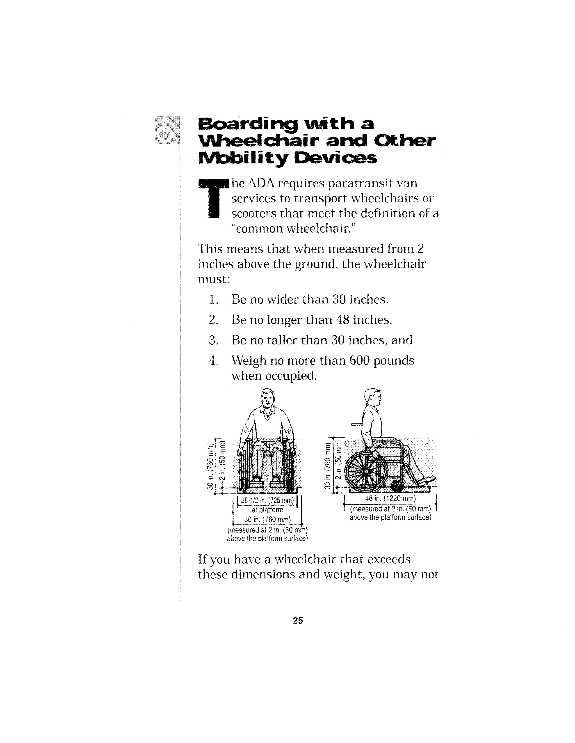Weigh up to six hundred (600) pounds when occupied.

TheHandi-Van lift may not work properly with a wheelchair that exceeds these dimensions and weight. Just as your wheelchair was measured at your In-Person interview to determine if it meets the definition, any new wheelchair you obtain should also be reviewed by   
TheHandi-Van Eligibility Center. Please contact the Center at 538-0033 to make the necessary arrangements for their review. For any further assistance, please call Oahu Transit Services, Inc. at 456‑5555.

Operators will assist you in and out of the van, on and off the wheelchair lift, and will fasten and unfasten the securement straps (tie-downs) inside the van.

**MOBILITY DEVICES**

If you use a wheelchair or other mobility aid, please keep it clean and in good condition. It can be a hazard to you, to the Operator, and to other customers if, for example, the wheels or other parts are loose, or the brakes do not hold the wheels securely.

***Note:***

***All mobility devices (wheelchair, scooter, walker, etc.) must be secured inside the van.***



## j0371304Scooters

MCj03713080000[1]Some three-wheeled scooters may be difficult to secure inside the van. Because of this, the Operator may ask you to transfer to the van seat for your safety. However, you are not required to transfer to the van seat.

## Other Aids

**MOBILITY DEVICES**

MCj03713020000[1]The Operator will secure **walkers** inside the van.

**j0360978Oxygen tanks** are mobility aids. They should be carried on the rider’s lap and/or must be in an approved carrier. The Operator will assist with securing oxygen tanks, if needed.

## The Lift

Please inform the Reservationist when booking your trip that you will need the lift. Any rider who prefers to board the van using the lift may ask the Operator to assist them.

## MCj03709240000[1]Safety Belts

All vans are equipped with seat belts. For your safety and security, you are required to fasten your seat belt and/or shoulder harness and remain seated while riding on TheHandi-Van. This applies to both ambulatory customers as well as those using a mobility device. Seat belt extensions are also available; just let the Operator know if you need one.

**MOBILITY DEVICES**

Undoing a seat belt and/or walking around in the van while it is in motion is not permitted.

We require that customers in wheelchairs also use a personal lap belt in order to help prevent falling or sliding out of the wheelchair seat during transport.

Failure to use the seatbelt and/or shoulder harness will result in a denial of your   
scheduled trip.

***Note:***

***Those with a written medical waiver may be exempt from this requirement.***



## Service Animals

MCj03316720000[1]Some people with disabilities have specially trained Service Animals to assist them in their daily life activities. Service Animals are welcome on TheHandi-Van when accompanying their owner. You must be registered with TheHandi-Van Eligibility Center as needing a Service Animal with you on your trips.

**MOBILITY DEVICES**

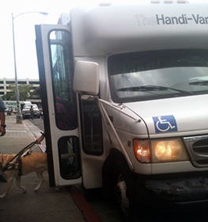Be sure to tell the Reservationist when you call to arrange your ride if a Service Animal will accompany you. This will ensure that room is reserved on the van for the Service Animal. There is no fare for a Service Animal.

If a Service Animal is out of control and the owner does not take action to control it, or the animal poses a direct threat to the health or safety of others, the Operator may refuse to transport the animal or take action to have it removed from the vehicle. MC900293228[1]

|  |  |
| --- | --- |
| j0293238 | Pets, Packages and Children |

## Pets

Pets are not allowed unless they are in a cage or carrier that can be stored under the rider’s seat or on the rider’s lap without inconveniencing other riders. If a pet is out of control and the owner does not take action to control it, or the animal poses a direct threat to the health or safety of others, the Operator may refuse to transport the animal or take action to have it removed from the vehicle.

**PETS, PACKAGES CHILDREN**

## Packages



TheHandi-Van is not a delivery service. You may carry only two (2) small pieces of luggage or bags you are able to manage by yourself. They should be light enough for you to carry and hold on your lap, or small enough that they can be placed under your seat without interfering in the movement of your fellow passengers during transport. If you are going shopping and anticipate carrying more than two (2) bags, other arrangements should be made.

***Remember:***

***Customers are responsible for their own bags, packages and other carry-on items.***



## Children

**PETS, PACKAGES CHILDREN**

Children under four (4) years of age (or under forty (40) pounds) must travel in an approved child seat. TheHandi-Van vehicles are not equipped with child seats, so you will need to bring one with you.

You are responsible for any children who accompany you during your trip. The van Operator will not lift your child onto a seat for you. If you need assistance getting your child seated, please arrange for someone to help you at the pickup and drop-off sites. MC900293228[1]

|  |  |
| --- | --- |
| j0293238 | Out-of-Town Visitors |

Visitors who require ADA paratransit service may use TheHandi-Van service for up to twenty one (21) days per three hundred sixty five (365) day period, after registering with TheHandi-Van Eligibility Center. Call (808) 538-0033 to register as a Visitor.

If a visitor uses the service more than twenty one (21) days in a three hundred sixty five (365) day period, they will be asked to submit an application to determine their eligibility. MC900293228[1]

**OUT-OF-TOWN VISITORS**

|  |  |
| --- | --- |
| j0293238 | TheHandi-Van Operators |

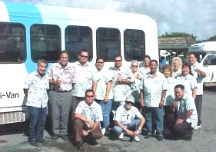OTS Paratransit Operators are trained in defensive driving, disability awareness, and the safe operation of TheHandi-Van vehicles. Please cooperate with the Operators and follow their instructions.

## Rules for Operators

✓ Operators may provide assistance to and from the vehicle and the door of the establishment if needed and requested by the rider at the time of trip reservation.

MCj01857520000[1]✓ Operators are not allowed to engage in unnecessary conversation with customers. If you have questions during your van ride, the Operator will gladly help; however, for safety reasons, distractions must be kept to a minimum.

**OPERATORS**

✓ Operators are not allowed to pick up packages (such as prescriptions or groceries) for you and bring them to you.

**OPERATORS**

✓ Operators are not allowed to wait while you “just go in here for a minute.” They must go on to pick up or drop off other customers. If you need a short time somewhere, tell the Reservationist when you book your ride and they will do their best to schedule a van to come right back for you. An additional fare is required when you get on the next van.

***NOTE: TheHandi-Van Operators and staff are not allowed to accept tips or gratuities. If a rider wishes to thank a particular person, please send a letter to:***



**OPERATORS**

Director

Department of Transportation Services

650 South King Street, 3rd Floor

Honolulu, HI 96813

OR

Vice President

OTS Paratransit

811 Middle Street

Honolulu, HI 96819

MC900293228[1]

|  |  |
| --- | --- |
| j0293238 **LOST & FOUND** | Lost and Found |

Articles found on TheHandi-Van will be turned in to the Customer Service Office. Articles will be held for forty five (45) days.

Contact Customer Service Monday through Friday, from 7:30 a.m. to 4:00 p.m. at 456‑5555 (voice) or 454‑5045 (TTY). MC900293228[1]

|  |  |
| --- | --- |
| j0293238 | Prohibited Acts and Misconduct |

**Prohibited acts include:**

* Consuming food or drink, unless required for medical reasons;

**PROHIBITED ACTS AND MISCONDUCT**

* Playing a radio, television, cassette or CD player without earphones;
* Bringing on pets that are not carried in a container that can be placed under the seat or on the rider’s lap;
* Littering;
* Carrying or possessing any flammable liquid or gas (other than medical oxygen);
* Knowingly failing to pay a fare;
* Knowingly urinating, or defecating on the vehicle;
* Using someone else’s pass or card;
* Threatening the Operator; and
* Doing or carrying anything that may cause harm or danger to other passengers or the Operator. MC900293228[1]

|  |  |
| --- | --- |
| j0293238 | Suspension of Service |

Service may be suspended to a cardholder for up to twelve (12) months at the discretion of the Director of the Department of Transportation Services (DTS) or the Director’s Designee for any violation of the rules or regulations of DTS or any other law or rule relative to   
TheHandi-Van. MC900293228[1]

**SUSPENSION OF SERVICE**

kvl

1. \* To notify TheHandi-Van of address, phone number, mobility aid or other information changes [↑](#footnote-ref-1)