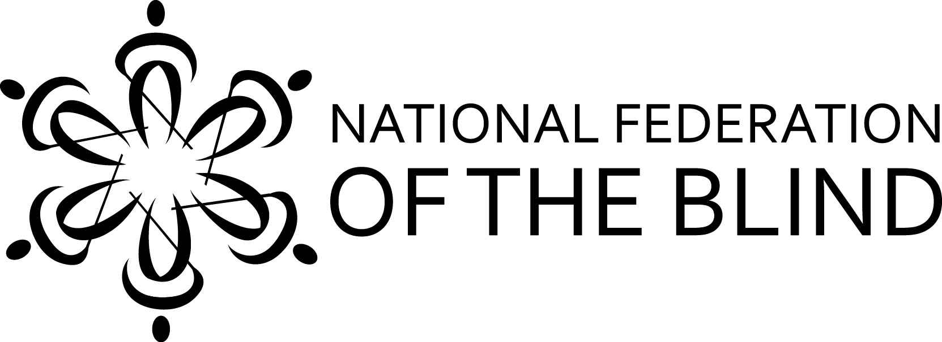
You are cordially invited to the
National Federation of the Blind of Hawaii
2018 Annual State Convention"

"Raising Expectations, Building our Federation"

WHEN: Friday September 28 – Sunday, September 30, 2018

Welcome BBQ: Friday: 6:00 pm
Tropic Seas Seawall, 2943 Kalakaua Ave.
Bus Routes: 19, 20, 22
Buses stop at Outrigger and Elks clubs. 2nd driveway to the left is Tropic Seas Inc.

General Convention: Saturday: Registration 8:00 am
Program: 9:00 am - 5:00 pm
Evening Networking Social: 5:30 pm, location TBA
Exhibits, Presenters, Awards, Scholarships, Networking and More!

General Convention: Sunday: Registration 8:00 am
Program: 9:00 am - 12:30 pm

WHERE: Ho'opono Auditorium. 1901 Bachelot St. Honolulu, HI. 96817

Please Register!
Registration: $50 Pre-Registration and at the door

Includes: Saturday, continental breakfast and lunch; and Sunday, continental breakfast

Remit checks, registration and mail to: NFB Hawaii, P.O. Box 4482, Honolulu HI 96812

For Further Information, call: Katie Keim (808) 722-4242
Email: 808keim@gmail.com
NFBH Voicemail: (808) 595-6123
Toll Free Neighbor Islands: (866) 595-6123

