The Power of Independence Through Assistive Technology

O‘ahu
Tuesday
September 11, 2018
9:00AM - 3:00PM
Registration begins at 8:30AM

HawaiiUSA Federal Credit Union
1226 College Walk
Honolulu, Hawai‘i, 96817
*Limited onsite parking
or
$10 for the day entry before 9:00am at the Chinese Cultural Plaza
Ask attendant on entry for Early bird special. Cash only!

Cost
Family & College Students
$35.00
Professionals
$50.00
Includes lunch

We encourage attendees to bring to the workshop:
- iPad or iPhone running at least iOS 10 or later
- Apple MacBook running Sierra

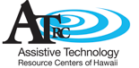

Description:
Workshop attendees will be tantalized by an exciting variety of assistive technology (AT) devices and services in our community. Presenters will discuss and demonstrate AT for the workplace, for the academic environment, and for the home.

This dual stranded workshop is designed for professionals and non-professionals alike who either work with or know a person with a disability. Teachers, therapists, case coordinators, direct service workers, college/university special education students, social workers, individuals with disabilities, and family members will significantly benefit from attending this event.
Agenda:
Time | Workplace | School
8:30-9:00 | Sign-in
9:00-9:15 | Introductions
9:20-10:20 | Technology for Work  (Dr. Min Ok)  University of Hawaii Manoa | AT Tools & Strategies for the classroom  (Dr. Christina Keaulana / Brent Hirata) LCC
10:30-11:40 | AT Work Strategies | AT, Part of IEP
11:45-12:45 | Lunch
12:55-1:55 | Augmentative Alternative Communication (AAC) and beyond for school and workplace
2:00-3:00 | Apple Tools, Access for work and school  (James Thorpe/ Jason Julian)
Learning outcomes: participants will be able to:
- Assess the latest in assistive technology products and services for school and the workplace
- Demonstrate Apple Accessibility features of the iPad/Apple laptop to support children and adults with disabilities.
- Increase knowledge of Independent living resources and supports (sponsored in part by Christopher and Dana Reeve Foundation)
- Identify assistive technology resources to the needs of individuals and children with whom you work.

In partnership with the Hawai‘i & Pacific Deaf-Blind Project, Easterseals Hawai‘i and the Assistive Technology Resource Centers of Hawai‘i. A special thank you to the DOH Early Intervention Assistive Technology staff for assisting with planning and photocopying handouts.

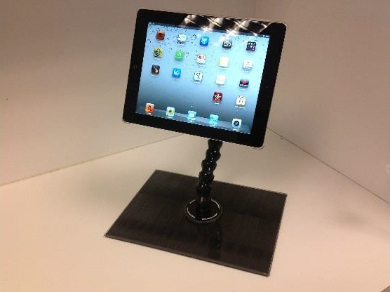

REGISTRATION

The Power of Independence Through
Assistive Technology

Return this form and payment to Derrick Sokolowski
by email: dsokolowski@eastersealshawaii.org
or by mail: Easterseals Hawai‘i, 710 Green St. Honolulu, Hawai‘i 96813
Deadline: Monday, September 10, 2018 12 noon
Name:

Agency: Position:

*First 15 participants to register will get free onsite parking. Would you like to be considered for onsite parking?

Please choose one Strand:

- School

- Workplace
Yes No
Networking and partnerships are encouraged at this event. Would you like your information to be included in our contact sheet (to be shared with other participants)?
Yes No

Address: City: State: Zip: Phone: Email:
I am a: parent or college student ($35) professional ($50)
Payment method: Check # (made out to Easterseals Hawai‘i)
Credit card Expiration security code
Visa Mastercard American Express Discover
Each attendee will receive a Certificate of Completion at the end of the workshop.
Do you have any dietary restrictions? No Yes (Please describe: )
For accommodation requests, contact Hannah Goldblatt at 808.532.7114 or hannah@atrc.org
by Wednesday, September 5, 2018

