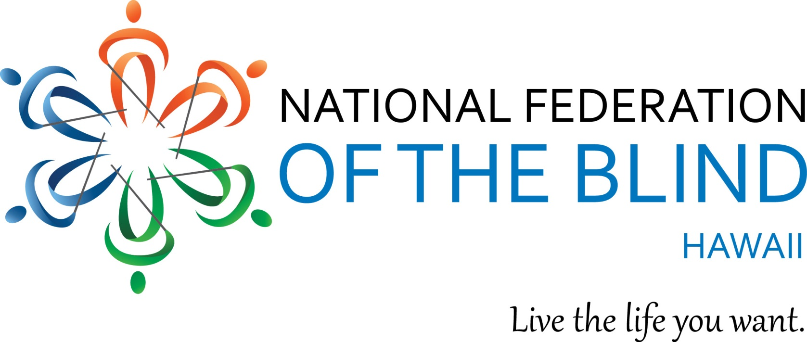

We are only 2 weeks away! We look forward to seeing you all, join us!

NFBH 2018 Annual State Convention"

Our Theme: "Raising Expectations, Building our Federation"

WHEN: Friday, September 28 – Sunday, September 30, 2018
FRIDAY: Tropic Seas Seawall, 2943 Kalakaua Ave.
SATURDAY: Ho'opono Auditorium. 1901 Bachelot St. Honolulu, HI.
SUNDAY: Ho'opono Auditorium. 1901 Bachelot St. Honolulu, HI.

We are excited to introduce our very own National Board Treasurer and this years National NFB Representative Jeannie Massay, President NFB of Oklahoma. She is looking forward to getting to know all of us; our guests, friends and federation family!

We welcome this year’s Convention with Friday night’s delicious BBQ along the ocean shore!
Welcome BBQ: Friday September 28, 2018 6:00 pm at our Tropic Seas Seawall, 2943 Kalakaua Ave.
Bus Routes: 19, 20, 22
Buses stop at Outrigger and Elks clubs. 2nd driveway to the left is Tropic Seas Inc.

Next is our all day general convention which includes exhibits, presenters, awards, scholarships, networking and more on Saturday September 29, 2018 at Ho'opono Auditorium. 1901 Bachelot St.
Registration: 8:00 am
Program: 9:00 am - 5:30 pm
Networking Social: 5:30 pm, nearby location TBA

We close our convention on Sunday September 30, 2018 at Ho'opono Auditorium. 1901 Bachelot St. for our final General Convention.
Registration: 8:00 am
Program: 9:00 am - 1:30 pm

$50 Pre-Registration and at the door
Please RSVP and Register!

Includes: Saturday, breakfast and lunch; and Sunday, breakfast and light snack
Remit checks, registration and mail to: NFB Hawaii, P.O. Box 4605, Honolulu HI 96812
For Further Information, call: Katie Keim (808) 722-4242
Email: 808keim@gmail.com
NFBH Voicemail: (808) 595-6123
Toll Free Neighbor Islands: (866) 595-6123

