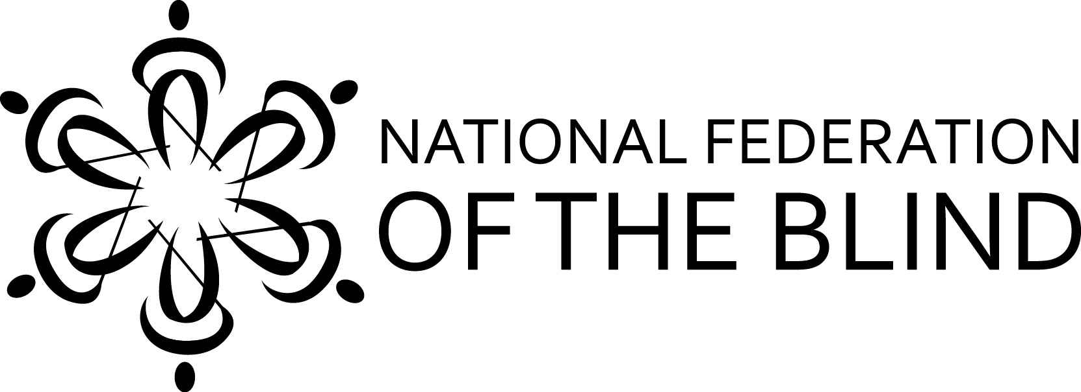

P. O. Box 4605
Honolulu, HI 96812
Phone: (808) 595-6123

NFBH State Convention
"Raising Expectations, Building Our Federation"

Dates: September 28, 29 and 30, 2018
Registration Fee: $50.00
Make checks payable to: NFB of Hawaii
Remit to: NFB Hawaii, P.O. Box 4605, Honolulu HI 96812
Questions call or email: Registration Chair, Tammy Robar 808-218-1542
Convention Coordinator, Katie Keim 808-722-4242

The 2018 NFB of Hawaii's State Convention will be held at 1901 Bachelot St. Honolulu, Hawaii in the main Auditorium. Parking is available in the lot designated for Ho'opono employees.

Please list all attending:
NAME, First and Last | Phone | Email | Registration Fee | Special Meal Request
 |  | Total

Mahalo,

Katie Keim
NFBH Convention Coordinator
808-722-4242 or 808keim@gmail.com

