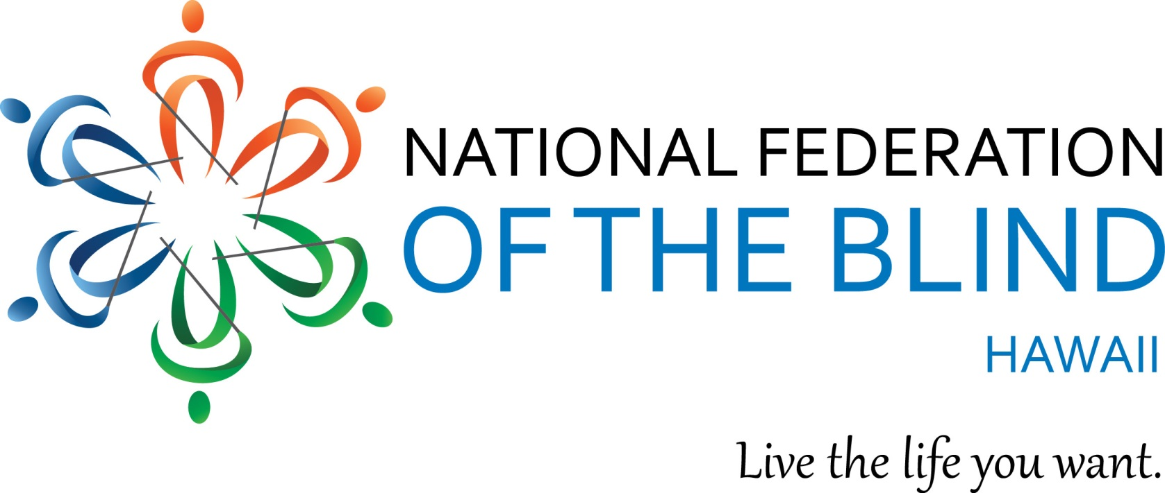

It's not too late! with only 2 days to go!
Everyone is invited, join us!

NFBH 2018 Annual State Convention"

Our Theme: "Raising Expectations, Building our Federation"

WHEN: Friday, September 28 – Sunday, September 30, 2018
FRIDAY: 6:00 PM Tropic Seas Seawall, 2943 Kalakaua Ave. Welcome BBQ!

SATURDAY: 7:30 - 8:30 AM Student Division 1901 Bachelot St. Conference Room, Honolulu HI

General Convention 8:00 AM Ho'opono Auditorium. 1901 Bachelot St. Honolulu, HI.

Saturday Social Networking - 5:30 PM Aloha Tower

SUNDAY: 8:00 AM Ho'opono Auditorium. 1901 Bachelot St. Honolulu, HI.

Oh yes, FUN, exhibitors, speakers and delicious food!

$50 registration at the door
Please RSVP and join us for a good time!

Includes: Saturday, breakfast and lunch; and Sunday, breakfast and light snack
Remit checks, registration and mail to: NFB Hawaii, P.O. Box 4605, Honolulu HI 96812
For Further Information, call: Katie Keim (808) 722-4242
Email: 808keim@gmail.com

