

NOVEMBER IS

DIABETES AWARENESS MONTH

Want to know more about Diabetes?

American Diabetes Association and the Lions Club want to educate you…

Featuring Speaker Dr. Jim Yamashita

Who: VIPs (Visually Impaired Persons) and their families and friends

When: Saturday, November 17, 2018

Time: 1:00 pm to 3:00 pm (PRESENTATION STARTS AT 1:30 pm)

Where: Pearl City Public Library, 1138 Waimano Home Road

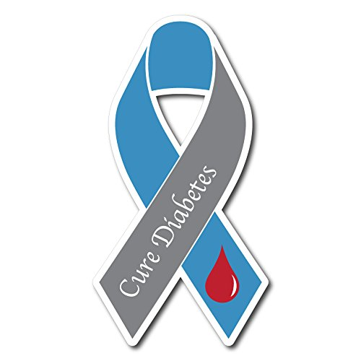

Learn about:

The Biology of Diabetes

Screening for Diabetes

The Treatment of Diabetes

Diet and Exercise

And enjoy a few diabetes friendly snacks

Please sign up by November 5 with Sharon Ige 892-9477 or email her at [sharonige003@hawaii.rr.com](mailto:sharonige003@hawaii.rr.com)

