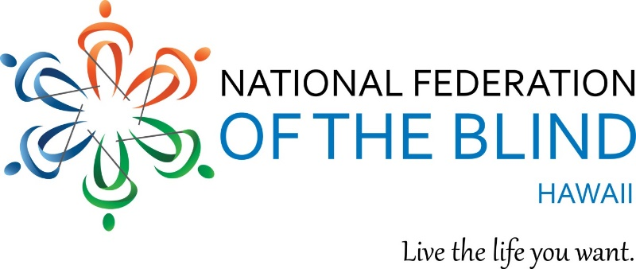

Aloha,

You are cordially invited to the National Federation of the Blind of Hawaii 2019 Annual State Convention!

Theme: "RAISE THE ROOF! BIGGER AND BETTER TOGETHER.”

WHEN: Friday, September 27 – Sunday, September 29, 2019
WHERE: Elks Lodge 2933 Kalakaua Avenue Honolulu, Hawaii 96815

We Kick off Friday September 27, 2019 at 3:00 PM with The National Association of Blind Merchants. That same evening we welcome everyone to our Opening Reception at 6:00 PM. Cash bar and Pupus available.

General Convention begins on Saturday September 28, 2019 with registration at 8:00 am; program begins at 9:00 AM and ends on Sunday at 1:00 PM.

Saturday evening, we have a fun filled banquet with our NFB National Representative, Norma Crosby, National board member and President NFB of Texas. Banquet Cash bar opening at 5:15 PM dinner banquet, awards, educational scholarships and keynote speaker 6:00 to 9:00 PM. And Don't forget Sunday, more to come until 1:00 pm!

All weekend long, join us for exhibitors, door prizes, speakers and more!

Please Register by submitting $50 Pre-Registration fee or at the door. Registration Includes: Your name in the hat to win door prizes! Friday Reception; Saturday breakfast, lunch, and evening banquet; and Sunday, breakfast.

Remit checks and registration form and mail to: NFB Hawaii, P.O. Box 4605 Honolulu HI 96812.

For Further Information, Contact: Tammy Rober by Phone: (808) 218-1542 or Email: snoopytdr@aol.com

Mahalo & Aloha,

Virgil Stinnett
1st Vice President, NFBH
808virgil@gmail.com
808-722-4243
www.hawaii.nfb.org

