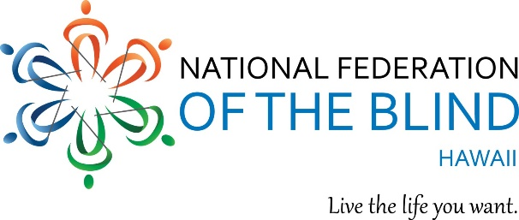

You are cordially invited to the National Federation of the Blind of Hawaii 2019 ANNUAL STATE CONVENTION!
September 27, 28 and 29, 2019

Theme: "RAISE THE ROOF! BIGGER AND BETTER TOGETHER!”

Join us Friday September 27 for our Special Interest Division Meetings.

NFBH National Association of Blind Students,
Kainalu room 5:00 - 6:00 PM

NFBH National Association of Blind Merchants,
Lodge Room 3:00 - 5:30 PM

NFBH Brail Division,
Kainalu Room 3:30 - 5:30 PM
Braille, Enrichment, Learning and Literacy

WHEN: Friday September 27, 2019
WHERE: Elks Lodge 2933 Kalakaua Avenue Honolulu, Hawaii 96815

Join us after our Division Meetings Friday at 6:00PM for our Opening Reception. Cash bar and Pupus.

Saturday and Sunday is our Main Convention, September 28 and 29, 2019 - All 3 days, join us for our Annual NFBH convention! fun, exhibitors, door prizes, speakers, good food and fellowship!

Please Register! $50 Pre-Registration and at the door. Registration Includes: Your name in the hat to win door prizes! Friday Division Meetings and Reception; Saturday, breakfast, lunch, Saturday Banquet; and Sunday, breakfast.

Remit checks, registration and mail to: NFB Hawaii, P.O. Box 4605 Honolulu HI 96812.

For further information, contact:
Tammy Robar
Phone: (808) 218-1542
Email: snoopytdr@aol.com

