Effective 10/13/19 to 11/26/19 (dates subject to change based on conditions), Kamehameha Highway will be closed at Laniakea Beach to Kawela Beach from 12:00 AM to 2:30 AM on Sunday through Thursday nights, except on 10/31/19 and 11/11/19, Haleiwa-bound Route 60 trips from Turtle Bay at 11:42 PM, 12:41 AM, 1:41 AM on weekdays, and 11:45 PM, 12:44 AM, 1:44 AM on Sundays will be affected as shown on the map below.

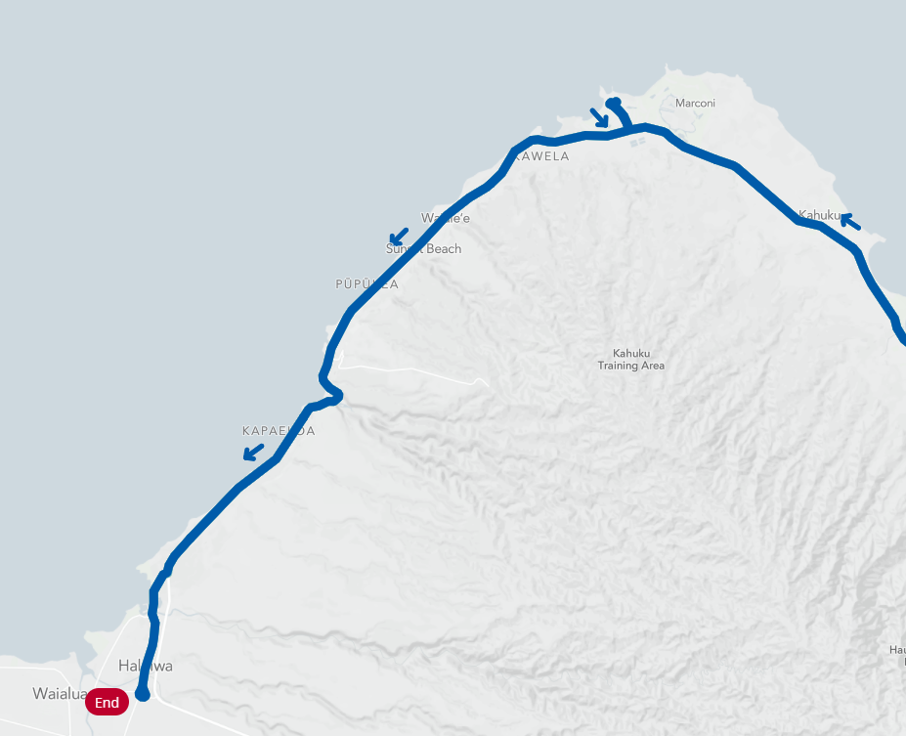
No Route 60 service Sunday to Thursday from 11:42 PM to 1:44 AM
Route 60 Ends at Turtle Bay

For information on the road closures, go to www.napuamakanihawaii.org/category/updates/ or call 888-519-2643.
For schedule and route information, go to www.thebus.org or call 808-848-5555, Press 2.

