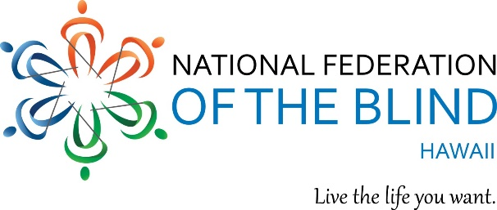

Please join us at a special joint meeting of the

BRAILLE DIVISION, BELL* ACADEMY, and
PARENTS OF BLIND CHILDREN

*Braille Enrichment for Learning and Literacy

This is an opportunity to meet other parents and their children, and help us plan Hawaii’s first Bell Academy to take place summer of 2020. The Bell Academy is a 2-week day program for blind and visually impaired children between the ages of 4 to 12 years, with FUN activities of reading, writing, science, math, technology, arts and crafts, cooking, mobility, field trips, and more, all of which include braille.

WHEN: Friday, September 27, 2019
3:30 to 5 pm

WHERE: Elks Lodge, 2933 Kalakaua Avenue, Honolulu, Hawaii 96815

And please stay for the 6:00 PM Opening Reception of the National Federation of the Blind of Hawaii Annual State Convention. Cash bar and Pupus.

General Convention begins on Saturday September 28, with registration at 8:00 am, program begins at 9:00 AM and ends on Sunday at 1:00 PM.

For further information, contact:
Debbie Gabe
754-2793
debbiegabe@live.com

