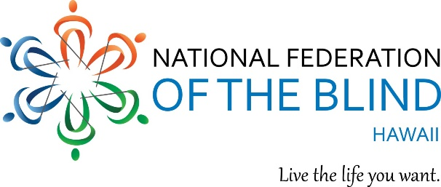

You are cordially invited to the National Federation of the Blind of Hawaii 2019 ANNUAL STATE CONVENTION!

Theme: "RAISE THE ROOF! BIGGER AND BETTER TOGETHER!”

WHEN: Friday, September 27 – Sunday, September 29, 2019
WHERE: Elks Lodge 2933 Kalakaua Avenue Honolulu, Hawaii 96815

We Kick off Friday September 27, 2019 at 3:00 PM with division meetings and at 6:00 PM with our Opening Reception. Cash bar and Pupus.

General Convention begins on Saturday September 28, with registration at 8:00 am, program begins at 9:00 AM and ends on Sunday at 1:00 PM. Saturday Banquet Cash bar opening at 5:15 PM dinner Banquet, awards, educational scholarships and keynote speaker 6:00 PM to 9:00 PM.

And Sunday, more to come until 1:00 pm!

All weekend long, join us for fun, Exhibitors, door prizes, speakers, good food and fellowship!

Please Register! $50 Pre-Registration and at the door. Registration Includes: Your name in the hat to win door prizes! Friday Reception, Saturday, breakfast, lunch, Saturday Banquet; and Sunday, breakfast.

Remit checks, registration and mail to: NFB Hawaii, P.O. Box 4605 Honolulu HI 96812.

For further information, contact:
Tammy Rober
Phone: (808) 218-1542
Email: snoopytdr@aol.com

