National Federation of the Blind of Idaho
Dana Ard, President
1320 E. Washington
Boise, ID 83712
Ph: (208) 345-3906
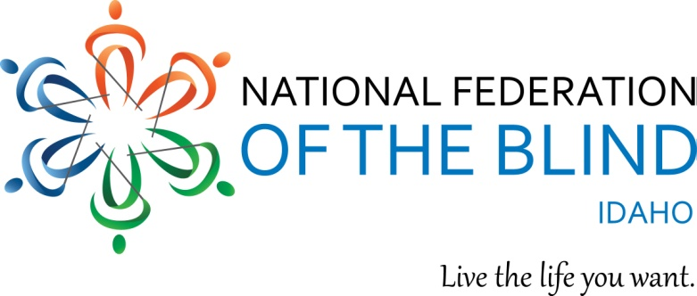

Dear Friend,

We, the National Federation of the Blind of Idaho are excited to announce our upcoming State Convention to be held April 22nd – 24th, 2016 in Lewiston, Idaho. We are asking for donations or sponsorship. We use our funds for travel and convention expenses, programs, scholarships and technology for the blind. All donors $100 and above will be listed in their categories on our state and local websites as well as our convention agenda. We welcome you to specifically sponsor a scholarship if you choose. Any donation would be greatly appreciated.

The National Federation of the Blind is the largest organization of blind and visually impaired in the world. The Federation’s purpose is to help blind people achieve self-confidence, self-respect and independence. We know that blindness is not the characteristic that defines you or your future. Braille is an important part of increasing literacy in blind people and we strive to improve the education of blind children through our summer Braille Enrichment for Literacy & Learning program. We provide many opportunities for the blind to be successful. We believe you can live the life you want; blindness is not what holds you back.

We appreciate your support and look forward to working with you as a sponsor or partner. If you provide a business logo we will print it in our convention agenda and show it on our website.

Sincerely,
Dana Ard, President
National Federation of the Blind of Idaho

We are tax exempt under 501 C (3) of IRS Code; Tax ID # 23-703-9334

Levels of Sponsorship:
Louis Braille, $1,000 and above
Helen Keller, 500
John Milton, $250
White Cane, $100
Supporting Sponsor, $50

