**National Federation of the Blind of Idaho**

**Dana Ard, President**

**1320 E. Washington**

**Boise, ID 83712**

**Ph: (208) 345-3906**

**danalynard@q.com**

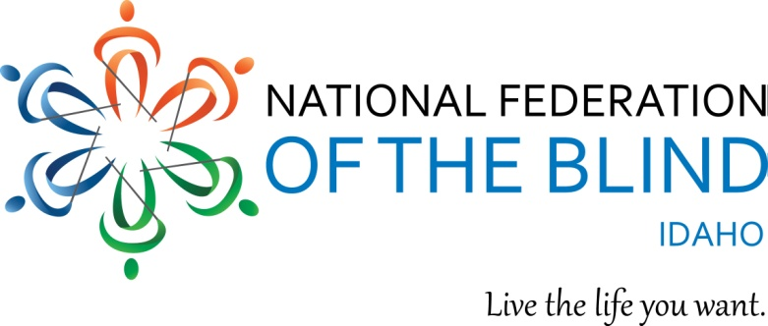

**2016 NFBI State Convention Registration**

**April 22-24, 2016 Lewiston, ID**

**Red Lion Hotel located at 621 21st Street, Lewiston, Idaho**

**Phone numbers (800) 232-6730 or (208) 799-1000**

Be sure to state that you are registering for the National Federation of the Blind convention and you want the room rate of $89.00.

**NAME**

**ADDRESS**

**CITY, STATE, ZIP**

**REGISTRATION FEE $15.00 PER PERSON (NUMBER x $15.00) $**

**BOARD DINNER $10.00 PER PERSON: (NUMBER x $10.00) $**

**SPECIAL DIET**

**LUNCH SATURDAY $10.00 PER PERSON: (NUMBER x $10.00) $**

**SPECIAL DIET**

**(lunch will not be provided in hospitality room on Saturday)**

**BANQUET: BEEF CHICKEN SPECIAL DIET**

**$30.00 PER PERSON (NUMBER x $30.00) $**

**TOTAL OF ABOVE**

Childcare will be available on Saturday during the General Session and the Banquet as well as on Sunday during the Business Meeting. For more information please contact Alison Steven at 208-761-6286 or email at [pecans65@gmail.com](mailto:pecans65@gmail.com).

Room rates are $89.00 for singles, doubles, triples, and quads, plus a tax of 8.00%.

The Hotel Reservation Deadline is March 22. Please send this form and payments to Harry Gawith 410 Avenue H, Boise ID 83712 or email at [harygawith@msn.com](mailto:harygawith@msn.com)

**Agenda Information**

The 2016 preconvention will begin on Friday, April 22, at 8:30 with a class on the Victor Stream instructed by Karl Smith from Axis. The preconvention expo will begin at 10:00 and will feature blindness product vendors, community service providers, NFB information and products, and other vendors and services of interest to blind and visually impaired persons. We will have a Senior Seminar and a student meeting. The board dinner is open to all and will take place Friday evening at 5:30. Resolutions committee will also meet prior to the Friday evening social.

Saturday will be our general session featuring our national representative Pam Allen, our National Association of Blind Students representative Mike Ausbun, a panel on transportation, state agency representatives, NFBI speakers and much more. Our banquet, featuring the address from our national representative, scholarship awards, and much more will take place Saturday night. We will have our business meeting, chapter reports and election on Sunday, but we will also have at least one special speaker.