ARTICLE YOU CAN PLACE ON YOUR WEBSITE OR NEWSLETTER – RED font, please feel free to add or modify as needed

HELP US COLLECT SURVEYS

Just as it is important to know that YOUR VOTE COUNTS, we need to know that you have the accessibility needed to MAKE IT COUNT; therefore we are collecting surveys to learn about the voting experiences of people with disabilities for the 2016 Election.

The Help America Vote Act (HAVA) was passed in 2002 to make sure everyone in this country can cast a private and independent vote. Now, we want to make sure the law is working for voters with disabilities.

YOU can help us do that by completing a survey developed by Self Advocates Becoming Empowered (SABE), Protection and Advocacy organizations and self advocacy organizations across the country.

We have two ways voters with disabilities can do that by January 1, 2017.

1. You can go on-line at the Self Advocates Becoming Empowered website, www.sabeusa.org or your state Protection and Advocacy organization’s website. Voters can do this independently or with help from someone, they choose. Here is the direct link to the survey: https://www.surveymonkey.com/r/2016VoterExperienceSurvey

2. Not everyone has access to a computer or the internet; so many self advocacy groups across the country are helping members complete the survey by filling it out by hand at a self advocacy meeting or conference. Surveys completed by hand need to be returned to your state or local self advocacy group or your state Protection and Advocacy organization. These need to be mailed to Essie Pederson, 5242 Sunrise View Circle, Liberty Township, OH 45044.

You may also reach out to the SABE Voter Team and complete the survey with them. You can contact Teresa Moore, SABE Voter staff person at mooreadvocacy@hotmail.com or (602) 725-3117.

Any problems making copies of the survey for meetings or postage to mail them to SABE; contact your state Protection and Advocacy organizations, add persons name and contact information or Essie Pederson, SABE Voter staff person at Essie.pederson@gmail.com or (513) 623-2566.

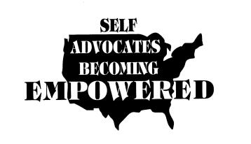

SABE is the United States national self-advocacy organization managed and operated by leaders in the self advocacy movement. Since 2002 SABE has operated The National Technical Assistance Center for Voting and Cognitive Access to help protection and advocacy systems, election officials and people with disabilities to make voting accessible for all citizens. www.sabeusa.org

ELP 10-19-16

