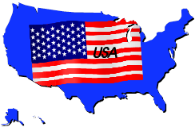
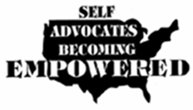
SABE Voter Project
Press Release

Help us make voting better for people with disabilities.

Self advocacy and Protection and Advocacy organizations are partnering with communities to collect information about the voting experiences of voters with disabilities for 2016 Election.

The SABE Voter Project needs your help this voting election year. This is not your typical survey collection; this is also a competition with other states to see who can get the most completed surveys to SABE by January 1, 2017.

The goal of the survey is to improve the voting process for everyone. We have many great laws like the Voting Rights Act of 1965, and the Help America Vote Act (HAVA) of 2002, that says that you have a right to a private and independent vote. Is that happening? We want to know. It starts when you arrive at your polling place, cast your ballot, exit the polling site, and everything in between.

What if every state worked together to gather voter information in one place? We could send powerful messages to the local, state and federal voting officials from people with disabilities.

For the collection competition, the state self advocacy team with the most completed surveys will be recognized by SABE, the national Self Advocacy organization. They will have an article written about their state team partnership with their P&A organization and other community partners in the SABE Nation newsletter. This would appear on the GoVoter page of the www.sabeusa.org website and be recognized in our Voter Project.

To participate in this contest, there must be a self advocacy and a P&A organization working together.

If you have any questions, contact Teresa Moore at 602-725-3117, email mooreadvocacy@hotmail.com

To get the Voter Experience Survey go to the SABE Voter Project’s website link https://www.surveymonkey.com/r/2016VoterExperienceSurvey.

