**National Federation of the Blind of Idaho**

**Ramona Walhof, Chair**

**Ph: (208) 338-1595**

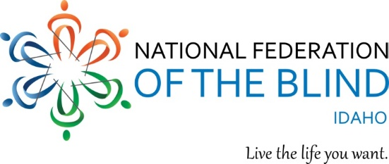

**NFB IDAHO ONLINE AUCTION**

**at nfbidaho.afrogs.org**

Great variety of items, hand-made, and donated from many companies!

**Thanks to all who have donated and to all who bid and buy!!!**

Values from $15.00 to $700.00

Variety includes - collectables: postage stamp, Barbie’s, bears, ammunitions crate; one-of-a-kind art: myrtle wood, copper relief, fine jewelry; appliances; food; baskets; motels; and items of special interest: such as piano tuning and iPhone 6-plus.

Each purchase will help the National Federation of the Blind of Idaho.

Bidding begins March 1, 2017 and continues until March 26, 2017 at 5:00 PM.  You will find instructions for pickup and pay on the site at **nfbidaho.afrogs.org**.

**National Federation of the Blind of Idaho**

**Ramona Walhof, Chair**

**Ph: (208) 338-1595**



**NFB IDAHO ONLINE AUCTION**

**at nfbidaho.afrogs.org**

Great variety of items, hand-made, and donated from many companies!

**Thanks to all who have donated and to all who bid and buy!!!**

Values from $15.00 to $700.00

Variety includes - collectables: postage stamp, Barbie’s, bears, ammunitions crate; one-of-a-kind art: myrtle wood, copper relief, fine jewelry; appliances; food; baskets; motels; and items of special interest: such as piano tuning and iPhone 6-plus.

Each purchase will help the National Federation of the Blind of Idaho.

Bidding begins March 1, 2017 and continues until March 26, 2017 at 5:00 PM.  You will find instructions for pickup and pay on the site at **nfbidaho.afrogs.org**.