National Federation of the Blind of Idaho
Dana Ard, President
1320 E. Washington
Boise, ID 83712
(208) 345-3906
danalynard@q.com
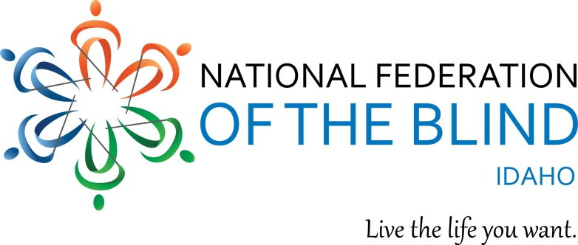

Donation Form and Receipt
National Federation of the Blind of Idaho
Tax I.D. # 23-7039334
Company
Address
City State Zip
Phone
E-Mail
Facebook Username and/or URL
You can follow NFB Idaho on our Facebook page
Donation:

NFB Idaho is a 501c (3) nonprofit organization.
Thank you for your support!

